TRESPASSING ENFORCEMENT PROGRAM

OBJECTIVE: | To give the owner, owner’s agent, or person in lawful possession a tool which will allow them to better manage their property; therefore creating a safer environment through enforcement.
APPLICATION: | - The owner, owner’s agent, or person in  lawful possession completes a Trespass Enforcement “APPLICATION.”  - If property meets the criteria, “NO  TRESPASSING” signs will be posted by the responsible party as outlined on page 3. After the signs are posted, a Barstow Police Officer will inspect the property to determine whether the posted signs are acceptable.  - After the authorization is complete, enforcement begins. A copy of all documentation should be kept for personal records.
MONITORING: | Documentation for this program will be kept and monitored by the Barstow Police Department.

Contact: (760) 256-2211.
Enforcement will be effective for one year (365 days), unless indicated otherwise. It is the responsibility of the owner, owner’s agent, or person in lawful possession to submit a written request to renew or cancel the enforcement program.

TRESPASSING ENFORCEMENT PROGRAM

PROPERTY NAME: __________________________________________________________

PROPERTY ADDRESS: __________________________________________________________
FOR OFFICIAL USE ONLY  Enrolling Officer |  | Badge # | Approval Date
As the legal owner, owner’s agent, or person in lawful possession of the above property, I hereby request and authorize the Barstow Police Department to enter the property and act as my agent, or advise any person to leave who is present on the property without lawful purpose or permission. I understand Barstow Police Department will act as my agent in my absence or after closing hours of my business. I authorize Barstow Police Department to arrest any violator, trespasser, or person on the property who is present without my consent or lawful purpose pursuant to PC 602(o). By signing below, I acknowledge I will fully cooperate in the prosecution of anyone who is arrested pursuant to a criminal violation, including state laws and local ordinances. I agree to appear in court if subpoenaed in any subsequent prosecution of a defendant. I understand this authorization to act as my agent will be effective for one year (365 days) from date of application approval, unless a written request for withdrawal is submitted. I agree to notify Barstow Police Department of change of ownership, Management Company, or any information related to enforcement on the property.

INITIAL APPLICABLE PARAGRAPH
 The abovementioned property is CLOSED to the general public and currently posted with “NO LOITERING”, “NO
TRESPASSING”, “NO GRAFFITI” and “NO PARKING” signs. (See Pages #3)
 The abovementioned property is conditionally OPEN to the general public while conducting business at the location. It is currently posted with “NO LOITERING”, “NO TRESPASSING”, “NO GRAFFITI” and “NO PARKING” signs. (See Pages #3)

OWNER OR AUTHORIZED AGENT INFORMATION
Printed Name |  | Telephone #
Driver License # | Birth Date | Email
Street Address | City | State | Zip
Signature |  | Date



INSTRUCTIONS FOR POSTING “NO TRESPASSING” SIGNS
- Signs MUST conform to the example below.
- Signs MUST be constructed of aluminum or galvanized steel. Signs MUST be securely attached onto a building(s) or post(s).
- The bottom of the sign MUST measure a minimum of 4 ft. above the ground, with a maximum of 10 ft. above the ground.
- Buildings or properties not entirely fenced or gated MUST display at least one sign per side at each entrance, displayed in plain view.
- Unimproved properties (without buildings, structures, etc.) MUST have signs visibly posted at every entrance, driveway, alleyway, trail, road, or any access point on to the property. In a case where signs cannot be affixed to a structure, signs MUST be securely mounted on a galvanized steel pole, which will be anchored into the ground. The bottom of the sign MUST measure at least 6 ft. above the ground.

If you have any questions pertaining to the outlined instructions, please call (760) 256-2211 prior to posting the signs.

- 16”-
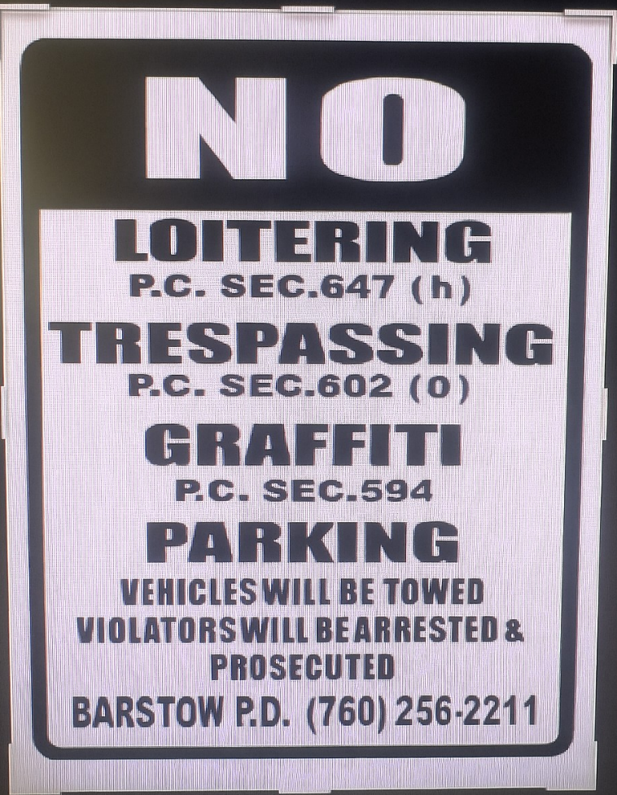
24’’

