
Engineering Department
Planning Department &
Public Works Departments

WATER QUALITY MANAGMENT PLAN (WQMP)
In compliance with State Water Resources Control Board
Water Quality Order No. 2013-0001-DWQ
National Pollutant Discharge Elimination System (NPDES)
General Permit No.: CAS000004
And the City Of Barstow Standards and Regulations for
Low Impact Development of Traditional Small Municipal Separate Storm Sewer Systems (MS4)
WDID# 6B36M2000222

Project Name

Address

City Ref: BGRD: XX-XXXXX

WQMP Preparation Date: MM/DD/YYYY

WQMP is considered Preliminary until City indicates “Approved” on this cover.
Submittal Status: |  | Preliminary Design, pending conditions  For Review:  Final Signatures  Other:
City Reviewer: | Date Received  Initials |  | Date Reviewed  Initials | Date Returned  Initials

Declaration of Responsible Charges
  - Engineer of Work
Initial

_ _ I acknowledge that each structural/treatment BMP is provided with adequate bypass or overflow so as not to contribute to localized flooding.
_ _ I have verified and applied the appropriate safety factor(s) when designing infiltration BMPs, including those suggested in the template, or generated in calculating software.
_ _ I have reviewed with the signing owner the contents of this WQMP, including: Site Design Methods, BMP types, costs, maintenance procedures and maintenance frequency required for this site in the Operations & Maintenance Section.
_ _ I have clearly consulted the signing owner of the potential damages and costs associated in the event of BMP failure due to function compromise, blockage, misuse, neglect, and/or failure of the BMP(s). Potential damages include those caused by inadequate protection during construction of the site. A Post-construction Infiltration Test may be required prior to Certificate of Occupancy
“I hereby declare that I am the Engineer of Work for this project and that I have exercised responsible charge over the design of the project as defined in Section 6703 of the Business and Professions Code, and that the design is consistent with current standards. I understand and acknowledge that the review of this Water Quality Management Plan (WQMP) by the City of Barstow is confined to a review and comment process, and does not relieve me, as Engineer of Work, of my responsibilities for project design.

As Engineer of Work, I agree to indemnify, defend, and hold harmless the City of Barstow, its officers, agents, and employees from any and all liability, claims, damages, or injuries to any person or property which might arise from the negligent acts, errors, or omissions of the Engineer of Work, my employees, agents or consultants”.

Engineer Name: | Engineer's Full Name | Place for Stamp
Company, Title: | Company, Title | Place for Stamp
Address: | Address | Place for Stamp
City, ST, ZIP | City, ST Zip | Place for Stamp
Email: | Email | Place for Stamp
Phone: | Phone | Place for Stamp

_____________ ______________________________
Signature Engineer of Work Date

Owner Certification
The Owner is responsible for the implementation of the approved provisions of this plan.

The Owner shall inform and notify any interested parties (e.g. future successors, facility operator, facility supervisors, employees, tenants, maintenance/service contractors, etc.) of the responsibilities under this WQMP.

The Owner shall ensure and have available, upon request, any necessary maintenance records as defined in the Operations & Maintenance (O&M) portion of this WQMP. This may include, but not limited to, inspection logs, disposal records, site/activities amendments, BMP improvements, etc. Such records may be required at any time, including owner transfer.

The undersigned Owner shall notify the City of Barstow of changes in ownership, including those within said company. The new successor will submit a new certification. (New Certification will include an updated signature on file, and may include, but not limited to, site evaluation, inspection of BMP(s), maintenance record evaluation, and redesign of BMP features/methods.)

“I certify under penalty of law that this document and all attachments were prepared under my direction or supervision in accordance with a system designed to assure that qualified personnel properly gather and evaluate the information submitted. Based on my inquiry of the person or persons who manage the system or those persons directly responsible for gathering the information, to the best of my knowledge and belief, the information submitted is true, accurate, and complete.

I am aware that there are significant penalties for submitting false information, including the possibility of fine and imprisonment for knowing violations.”

Owner’s Information
Name: | Owner Full Name
Title: | Title
Company Name: | Company Name
Address: | Address
 | City, ST Zip
Phone: | Phone
Email: | Email

_________________________________________________________________________
Owner Signature Date

Project Description
- Assessor Parcel Number(s): | Click or tap here to enter text.

Central location of project. (Additional locations will be required for each BMP in Section 9 & 10)
- Latitude  (decimal; 5 spaces minimum): | Click or tap here to enter text.
- Longitude²  (-decimal; 5 spaces minimum): | Click or tap here to enter text.

- Is Project/Site or construction activities subject to San Bernardino County Flood Control District, or other environmental/easement jurisdictional requirements? | N/A | Yes
- If “Yes”, describe (include copy(ies) of encroachment/permit requirements as Attachment I).
Notes:
Click or tap here to enter text.

Project Type
Select one:
- New Development:  No existing structure(s) on site. | N/A | Yes

Or,
- Redevelopment:  - Results in an increase of more than 50% of the impervious surface of a previously existing development. | N/A | Yes
- Results in an increase of less than 50% of the impervious surface of a previously existing development | N/A | Yes
- Is Demolition of an existing structure required?  Describe: | No | Yes

Development Type
- Standard Industrial Code: https://www.osha.gov/pls/imis/sicsearch.html  https://www.naics.com/search/ | Click or tap here to enter text.
- Proposed Land Use/describe project: | Click or tap here to enter text.

Select and follow instructions if any of these apply:

Industrial/Commercial Project:
- Yes, this project/Site activities are subject to the General Industrial Permit? | N/A
- Yes, this project is considered industrial/commercial development but does not require coverage under the GIP. | N/A

Residential Housing Subdivision:
- Yes, Multi-unit (Condos, Apartment, Community, etc.). Refer to O&M Instructions | N/A
- Yes, Single Family Residential Units – 5 or more adjacent units within the same tributary drainage/discharge area. | N/A

Phased Project:
- Yes. Phased, or stop of construction. | N/A

Linear Underground/Overhead Project:
- Yes. Project is within a discrete location and new impervious surface totaling 5,000 sq ft or more will be constructed in a contiguous (attached) arrangement. | N/A

Road Improvements
- (New, widening lengthen, etc.)  Yes, road improvements will remain on private land after completion. Include in Section 3.2, Items #1 & #2. | N/A
- Yes, road improvements will be constructed as part of the project but will belong and be maintained by the city after completion. Provide in Section 3.2 #A & #B. | N/A
- Yes, some right of way improvements will be part of the project, but equal less than 5,000 square feet in area. The amount is provided in Section 3.2. | N/A
- No, right of way improvements. Any utility connections will follow city standards | N/A

Other
- Use to describe project (if needed):
Click or tap here to enter text.

Site Assessment

Design Evaluation

Define the development envelope and protected areas
- Yes, there are protected area(s). They are shown in the WQMP Exhibit Plan. These areas will be shown on the Erosion Control Plan to be “Off Limits” or “PROTECT IN PLACE” during construction activities because:
  - existing features:
  - new infiltration/BMP location shall not be compacted:
- Yes, design preserved existing significant trees. Provide Form 4.2.4.
- No protected area(s) or set-backs.

Concentrated development based on Soils Type

- For Preliminary review:  Hydrologic Soils Group shall be provided: https://websoilsurvey.nrcs.usda.gov/app/WebSoilSurvey.aspx | Click or tap here to enter text.
- For Infiltration designs an engineered signed Geotechnical Study/Soils Report is required. Provide soils description here and provide report as Attachment III. | Click or tap here to enter text.
- Describe additional information:
Click or tap here to enter text.

Groundwater depth (ft):
- https://ca.water.usgs.gov/mojave/mojave-water-data.html  Provide reference as Attachment II | Click or tap here to enter text.

Site constraints
- No site constraints.

- Yes, based on the information above. Alternative methods are described:
Click or tap here to enter text.

Site Assessment Requirement Summary
One or more of the following methods is used as part of design.
- Defined the development envelope and protected areas, identifying areas that are most suitable for development and areas to be left undisturbed.
- Concentrate development on portions of the site with less permeable soils and preserve areas that can promote infiltration.
- Limit overall impervious coverage of the site with paving and roofs.
- Conform the site layout along natural landforms.
- Avoid excessive grading and disturbance of vegetation and soils.
- Replicate the site's natural drainage patterns.
- Detain and retain runoff throughout the site.
IF NONE – Describe why: Click or tap here to enter text.

Project Areas

Total Disturbed / Construction Area
All projects shall provide an Erosion Control Plan for review.
(on & off site) |  | - ft² | - Acre
 |  | Enter Sq. Ft. | Enter Acres
Does the project disturb one or more acres? | Yes, It is recommended not to apply for the WDID# until plans are approved.
Does the project disturb one or more acres? | No, All projects regardless of size are required an Erosion Control Plan

Improvements areas
ROAD IMPROVEMENTS | - ft² | - Acre
This area shall include only those areas that are to be paved road, curb, sidewalks and to be maintained by City after development is completed | Enter Sq. Ft. | Enter Acres

PROJECT WQMP AREA TOTAL | - ft² | - Acre
 | Enter Sq. Ft. | Enter Acres

Pre-Project Conditions
Pervious |  | Impervious
- Area (ft²) | - Percentage | - Area (ft²) | - Percentage
Enter Sq. Ft. | Enter Sq. Ft. | Enter Sq. Ft. | Enter Sq. Ft.

Post-Project Conditions
Pervious |  | Impervious
- Area (ft²) | - Percentage | - Area (ft²) | - Percentage
Enter Sq. Ft | Enter % | Enter Sq. Ft. | Enter %
Is this a Redevelopment project where impervious area is increased by 50% or more?  Yes, and Item 3 reflects the entire property, not just remodel area.  Yes, but the improvements will NOT increase impervious surfaces more than 50%.  No, this is not a Redevelopment Project. |  |  |  | N/A no adjustments

Does the project create or replace one acre or more of impervious surface?
Yes, It is advised to Address Section 6 - Hydromodification Management, next and determine
Pollutants of Concern prior to determining BMPs
No, Hydromodification Management is not required. Proceed to Section 4

Drainage Area Forms

Design Capture Volume Form
Provide for each Drainage Area. Each DA requires a BMP.

Drainage Area # |  |  |  | # Description
 | Drainage Area  (Tributary Drainage Area going to BMP) | ft² | Click or tap here to enter text.
 | Impervious Site Area (I)  (Proposed Impervious Area) | ft² | Click or tap here to enter text.
 | Percent Impervious  (=Item 2 / Item 1) | % | Click or tap here to enter text.
 | Watershed Impervious Ratio  (=Item 3 (%/100) | i | Click or tap here to enter text.
 | Composite Runoff Coefficient  (C = 0.858i^³ - 0.78i^² + 0.774i + 0.04) | C | Click or tap here to enter text.
 | Point Rainfall for 2-Year 1-Hour Rainfall  http://hdsc.nws.noaa.gov/hdsc/pfds/sa/sca_pfds.html | (in) | Click or tap here to enter text.
 | Regression Coefficient (Desert = 1.2371) | Rc | 1.2371
 | 6-hour Mean Storm Rainfall P6= Item 6(in)*Item 7 | P6 | Click or tap here to enter text.
 | Drawdown Time (48 Hour = 1.963) | 48 | 48
 | Drawdown Regression Constant (a) | (a) | 1.963
 | Design Capture Volume (ft3)  DCV= (Item 1*C*P6*a) / 12 | DCV | Click or tap here to enter text.
 | Round up Item #11 to solid number  this is the 85th percentile Design Capture Volume required to be retained and infiltrated on site. The sum of all DCV from all Drainage Areas must infiltrate on site after being treated for pollutants. | DCV ft³ | Click or tap here to enter text.

omitted

Does Item 1 include a new roof surface?
Yes, Section 4.3.2 is provided, or, No, continue to Item #15 below
Does DA have any of the activities listed high pollutant potential, or has soil type determined this area infeasible for infiltration?
Yes, Biotreatment and/or flow thru BMPs are provided.
No, this Drainage Area is addressed in following Section.
Notes: Click or tap here to enter text.

Site Design Selection
Check Box | Site Design Measures | Use Form
 | Tree Planting and Preservation:  Planting and preservation of healthy, established trees that include both evergreens and deciduous, as applicable;  - Refer to city approved plant list  - Tree canopy credit can be used in addition to volume if tree wells are created to receive and infiltrate runoff. Include Form 4.3.X | 4.3.1
Required all projects | Rooftop and Impervious Area Disconnection:  Routing runoff from impervious surfaces areas, such as rooftops, concrete walkways to adjacent pervious areas (landscaped, or gravel) instead of the storm sewer; or offsite.  - Downspout to extend at least 2 feet from concrete slab or building structure and pointed accordingly.  - Show roof-top area (size, sq. ft.), location/direction of down-spout, and landscaped area (sq. ft.) on WQMP Exhibit.  600 Sq.Ft. or less per downspout. | 4.3.2
 | Vegetated or Rock-lined Swales  Vegetated (landscaped) or decorative rock-lined open-channel management practice designed specifically to treat and attenuate storm water runoff;  - To be regularly maintained as part of grounds maintenance | 4.3.3
 | Setbacks and Buffers  Vegetated area including trees, shrubs, and herbaceous vegetation, that exists or is established to protect adjacent structures/outfalls.  - Refer to city approved plant list | 4.3.1  4.3.2 if impervious to pervious
 | Soil Quality Improvement and Maintenance  Small area soil improvements (amended) that creates infiltration depression with healthy soils (such as, tree wells, Rain-Gardens, decorative landscaped features that will become saturated during rain event and will infiltrate within 48 hours.  - Does not calculate underlined soils. | 4.3.3
Porous Stabilized Surfaces/Pavement
Allows runoff to pass through it, thereby reducing the runoff from a site and surrounding areas and filtering pollutants
- Only within property boundaries, to be maintained by owner;
Rain Collection Systems
That collects and stores storm water runoff from a roof or other impervious surface, to later use for irrigation purposes. Other collection systems, such as dry-wells, underground percolation systems, etc. shall be described in Items 26 or 27, and provide manufacture’s specifications as an Attachment.
- Maintained by owner, ensuring organic material and mosquito free
If NONE of the above Site Design Measures are applicable to the site, describe reasoning and alternative method:
Click here to enter text.

Primary Retention Forms
FIRST STEP
A MINIMUM of 1 (one) of the following “yellow” forms in Section 4.3.1 – 4.3.3 are required if there were no site constraints as shown in Section 2.2
Data from engineering software is accepted in lieu of forms provided, reference San Bernardino Hydrology Manual.
Insert calculations or spread sheets as Form # or objective.
Calculation results MUST be clearly highlighted or indicated.
Site Design | Form # | BMP Purpose | Applications (such as: | Calculation¹ | Variables
Credit Volume for Preserving Existing Trees onsite and/or Planting New
SD-10  SD-12 | 4.3.1 | Preserve, Conform, Minimize & Evapotranspiration | - Preserving / Planting of new trees | Vret = ntrees * IAcanopy *  dint / 12 | ntrees = number of street trees  IAcanopy = average impervious area under tree canopy after 4 years growth (ft2)  dint = rain depth retained by canopy interception (in)
SD-10  SD-12 | 4.3.2 | Dispersion, Evapotranspiration, & Retention | - Roof and impervious surfaces to pervious areas | Vret = DAimp * R * 0.5/12 | DAimp = impervious drainage area (ft²)  R = ratio of previous to impervious area  (per SBC Mojave Technical Guide Table 5-4)
SD-11 | 4.3.3 | Localized On-lot Infiltration | - Roof to gravel garden,  - Impervious to Planter island with curb or other surface depressions | Vret = (SApond * dpond) +  (SAmatrix * dmatrix * nmatrix) | SApond = surface area for ponding water (ft2)  dpond = depth of ponding water (ft)  SAmatrix = surface area of amended soil / gravel (ft2)  dmatrix = depth of amended soil / gravel (ft)  nmatrix = porosity of amended soil / gravel
¹ The governing document for discrete hydrologic analysis in San Bernardino County is the San Bernardino County Hydrology Manual (SBCFCD, 1986) and related Addendum for Arid Regions (SBCFCD, 2010). The calculations provided within utilize calculations from the Mojave River Watershed Technical Guidance, 2016 that reference (combine) Technical Release 55 (TR-55); Urban Hydrology for Small Watersheds (NRCS 1986). Forms provided in this section are for reference, engineer shall ensure certainty.

Tree Preservation & Planting for Landscaping: SD-10, SD-12
Onsite Tree Credit
Optional form used for credit(s). Onsite trees that will include tree well(s) to retain run-off (e.g., Rain Garden, disconnection depression)can be added to Form 4.3.3 for additional volume retention.

Planting and preservation of healthy, established trees that include both evergreens and deciduous, as applicable.
N/A: This form not utilized in design. See Form 4.3.2.
Drainage Area #: |  | Click or tap here to enter text.
 | Number of Preserved Significant Trees  Indicate on WQMP Exhibit Plan and Erosion Control Plan “to protect in place” |  | Click or tap here to enter text.
 | Average Area of existing tree canopy (ft²) |  | Click or tap here to enter text.
New trees within impervious surroundings (e.g. parking lots, and/or landscape islands).
Provide Landscape plans as Attachment VIII
 | Number of new Evergreen trees |  | Click or tap here to enter text.
 | Average area of canopy cover after 4 years of growth (ft²) |  | Click or tap here to enter text.
 | Number of new Deciduous trees |  | Click or tap here to enter text.
 | Average area of canopy cover after 4 years of growth (ft²) |  | Click or tap here to enter text.
 | Retention volume achieved from canopy interception (ft³)  V=[(Item 1*Item 2)+(Item 3*Item 4)+(Item 5*Item 6)] * (0.05/12) |  | Click or tap here to enter text.
Notes: Click or tap here to enter text.

Roof / Impervious Area Dispersion Form: SD-10, SD-11
Design Criteria:
Existing soils shall have a Hydrologic Group Rating of “A” or “B”, unless amended mixture is added or Geotechnical/Infiltration Reports indicates applicable conditions.
Soils shall be uncompacted and unaffected by construction materials or activities where pH or soil health compromises vegetative growth. Delineate in the Erosion Control Plan.
The previous area shall be a minimum of 50% of the impervious area.
Pervious receiving shall be < 2% slope and path lengths of >20 feet per 1,000 Sq.Ft of impervious surface area).
If > 600 ft² of roof at one downspout pipe, a dissipation method (splash block or rip-rap) is required. Show dissipation method(s) (e.g., splash block, or gravel rip-rap) as a detail on Exhibit. Show roof ridgelines with area size in Exhibit.
Impervious surfaces to Gravel Flat Surface
N/A: This form not utilized in design. See Form 4.3.3.
Drainage Area #: |  | Click or tap here to enter text.
 | Drainage Management Area (DMAs) #  If more than one pervious surface |  | #1 | #2 |  | #3
 | Enter Surface type (such as Concrete pad, Walkway, Rooftop,) |  | Enter type | Enter type |  | Enter type
 | Impervious Area (ft²)  DAimp:  (Show/label on Exhibit where roof ridge divides and directional arrows. Hatch or show surface types. |  | Click or tap here to enter text. | Click or tap here to enter text. |  | Click or tap here to enter text.
 | Pervious area receiving  (Uncompacted native non-polluted Hydrologic Soils Group “A” or “B”. |  | Click or tap here to enter text. | Click or tap here to enter text. |  | Click or tap here to enter text.
 | Ratio of pervious area (receiving) to impervious  R: (Item #2 / Item #1), |  | Click or tap here to enter text. | Click or tap here to enter text. |  | Click or tap here to enter text.
 | Retention volume achieved from impervious area dispersion (ft³)  Vret = Item #1 * Item #3 * (0.5/12), assuming retention of 0.5 inches of runoff |  | Click or tap here to enter text. | Click or tap here to enter text. |  | Click or tap here to enter text.
 | Retention Sums of Item #4 (ft³) |  |  |  | Click or tap here to enter text.
Notes:
Click or tap here to enter text.

Infiltration: Small Area Localized : SD-11
Use this form for desert landscaped infiltration areas (rock gardens), and small parking islands with curb cuts where runoff will fill the depression and infiltrate. This is also applicable to areas where soil Hydrologic Group “C”- “D”, or unknown, and where amended soils will be added. Provide cross section detail with depth dimensions in WQMP Exhibit
Design Criteria:
A single on-lot infiltration area should not be sized to retain runoff from impervious areas greater than 4,000 sq. ft.; if the drainage area exceeds this criterion, sizing should be based on calculations for bioretention areas or infiltration trenches.
Soils should be sufficiently permeable to eliminate ponded water within 24 hours following a 85th percentile, 24-hour storm event.
Side slopes of depression storage should not exceed 3H:1V.Effective energy dissipation and uniform flow spreading methods should be employed to prevent erosion resulting from water entering infiltration areas.
Soils should be preserved from their natural condition as much as possible and with a Hydrologic Group Rating of “A” or “B”, or soil amendments may be necessary.
A minimum of 1-part pervious area per every 2-parts of impervious area disconnected, and with velocity not greater than 0.5 ft per second to avoid scour.
The pervious area receiving flow should have a slope ≤ 2 percent and path lengths of ≥ 20 feet per 1,000 Sq.Ft. of impervious area. Show elevations, contour lines, etc., to determine slope maximum is met.
Dispersion areas should be maintained to remove trash and debris, loose vegetation, and protect any areas of bare soil from erosion.
Area is to provide a Set-back or Buffer and shall remain weed free and the responsibility of the owner for maintenance.
Localized rain-gardens, parking landscaped islands, and other small surface depressions
N/A: This Form not utilized because Forms 4.3.1 and/or 4.3.2 is provided.
Drainage Area #: |  | Click or tap here to enter text.
Drainage Management Area (DMA) #: |  | Click or tap here to enter text.
 | Total impervious surface draining to native, uncompacted, non-landscaped pervious area (ft²): |  |  | Click or tap here to enter text.
 | Pervious Surface type:  (e.g., “landscaped island”, “rock rain garden”, etc.) |  |  | Click or tap here to enter text.
 | Ponding surface (ft²)  SApond: area determined to be the most infiltrating. |  |  | Click or tap here to enter text.
 | Ponding depth (ft)  Dpond: Min.0.5 ft - max. 1.0 ft. No ponding >48 hours. Top surface to overflow |  |  | Click or tap here to enter text.
 | Surface area of amended surface media/soil/gravel (ft²)  SA matrix: New soil media or uncompacted native soils with healthy organic structure. If not amended, “0”. Desert landscape the area of new plants |  |  | Click or tap here to enter text.
 | Average depth of amended surface media/soil/gravel (ft)  dmatrix: If not amended, “0”. |  |  | Click or tap here to enter text.
 | Average porosity of amended surface media/soil/gravel  nmatrix: Average rates: gravel +/-=0.33, or composted/media soils=0.25, |  |  | Click or tap here to enter text.
 | Retention volume achieved from non-bioretention infiltration (ft³)  Vret = (Item 3 * Item 4) + (Item 5 * Item 6 * Item 7) |  |  | Click or tap here to enter text.
 | Retention Sum of Item 8 (ft³) |  | Click or tap here to enter text.
Notes:
Click or tap here to enter text.

DCV Achieved:

Total DCV required (ft³)  From Form4.1 Item 12 |  | Click or tap here to enter text.
 | Total Retention volume achieved from Section 4.3.1  (Tree Credit) Item #7 (ft³) | Click or tap here to enter text.
 | Total Retention volume achieved from Section 4.3.2  (Roof/Impervious Dispersion) Item# 5 (ft³) | Click or tap here to enter text.
 | Total Retention volume achieved from Section 4.2.3  (Small Area Amended Localized Retention “Rain Garden”) Item# 9 (ft³) | Click or tap here to enter text.
 | Total sums (Items 1 + 2 + 3) | Click or tap here to enter text.
If #4 is “0” (zero), provide descriptive reasoning #5 below:
Per 2013-0001-DWQ Phase II Small MS4 General Permit, Section E.12.e.ii.d. Site Design Measures,
“…Site design measures shall be used to reduce the amount of runoff, to the extent technically feasible, for which retention and runoff is required. Any remaining runoff from impervious DMAs may then be directed to one or more bioretention facilities as specified in Section E.12.e.(ii)(f), below.”
The city recognizes this requirement as using rain as a resource wherever possible.
Section 4.3.1 through 4.3.3 Site Design Measures Forms will most likely not retain the entire DCV. The permit contains no numeric value for Regulated projects therefore ANY amount in Item #4 satisfies this requirement.

However, small areas do not always provide suitable conditions [such as those described in Section E.12.e. ii. (f) – (i)] for bioretention or doing so creates worst situations or unrealistic upkeep. If necessary, #5 shall include rational description(s) that match the Site/Grading Plan and/or provide potential negative impacts. Item #4 can be “0” when Pollutants of Concern are Medium to High Risk and treatment of run-off is necessary prior to infiltration.
 | Click or tap here to enter text.

 | Remaining DCV to address in Section 5  (Total Section 4.1, Item #12) – (Item #4) | Click or tap here to enter text.

Pollutants Of Concern

General Pollutants of Concern Determination Form
Check all land uses or activities projected within each DA for the remaining DCV.
General Land Uses  Select land use applicable to DA/DMA |  | Drainage Area/ DMA #: | General Pollutant Categories
 |  | Drainage Area/ DMA #: | Suspended Solids/ Sediments | Nutrients | Trash & Debris |  | Heavy Metals | Pathogens (Bacteria/  Virus) | Oil & Grease | Toxic Organic Compounds | Oxygen Demanding Substances
 | Parking Lots** | Click or tap here to enter text. | E⁽¹⁾ | E⁽¹⁾ | E |  | E | E⁽⁶⁾ | E | E⁽⁴⁾ | E⁽¹⁾
 | Roads/Streets | Click or tap here to enter text. | E | E⁽¹⁾ | E |  | E | E⁽⁶⁾ | E | E⁽⁴⁾ | E⁽¹⁾
 | Light Commercial Development (pervious surface)** | Click or tap here to enter text. | E | E | E |  | N | E | E | E⁽¹⁾ | E
 | Industrial/Commercial Development (various)* | Click or tap here to enter text. | E⁽¹⁾ | E⁽¹⁾ | E |  | E | E⁽³⁾ | E | E^{(1,5)} | E⁽¹⁾
 | Residential Developments**: | Click or tap here to enter text. | E | E | E |  | N | E | E | E⁽¹⁾ | E
 | Vehicle Wash Bays Facilities and services*: | Click or tap here to enter text. | E | E | E |  | E | E | E⁽²⁾ | E | E⁽¹⁾
 | Automotive Repair Shops*: | Click or tap here to enter text. | N | N | E |  | E | N | E | E^{(1,4,5)} | N
 | Restaurant/Fast food Development* | Click or tap here to enter text. | E⁽¹⁾⁽²⁾ | N | E |  | E⁽²⁾ | E | E | E⁽¹⁾ | E
 | Retail Gasoline Outlets* | Click or tap here to enter text. | N | N | E |  | E | N | E | E⁽⁴⁾ | N
KEY:
E = Expected.  N = Not Expected  (1) Expected pollutant if landscaping or open area is present on site.  (2) Expected pollutant if the project includes uncovered parking areas. |  |  |  |  |  | (3) A potential pollutant if land use involves animal waste  (4) Including petroleum hydrocarbons.  (5) Including solvents.  (6) Bacterial indicators are routinely detected in pavement runoff.
Common activities (but not all) are listed. The Engineer and Owner shall provide adequate site-specific analysis.
Additional Notes: Click or tap here to enter text.
- *Projects require treatment prior to infiltration. **Projects require landscaped infiltration unless heavy Pollutants of Concern apply.

Treatment Control Table: 5.1
Performance Ratings are relative. Select the BMP category(ies) and the primary POCs established from Section 5.1. The city requires that all projects address Trash/Debris, Sediment, and Oil/Grease from parking lots. Provide specifications and/or calculations selected.
Pollutant of Concern  Check Box to verify as determined in Section 5 as “Expected” | Treatment Control BMP Categories⁽⁴⁾
 | Veg. Swale /Veg. Filter Strips / Open Landscaped | Detention Basins⁽¹⁾ | Infiltration Basins & Trenches/Porous Pavement⁽²⁾⁽⁴⁾ ⁽without discharge) | Water Quality Inlets | Hydrodynamic Separator Systems ⁽³⁾ | Manufactured/ Proprietary Devices
Sediment/Turbidity | H/M | M | H/M | L | H/M  (L for turbidity) | U
Nutrients | L | M | H/M | L | L | U
Toxic Organic Compounds | U | U | U | L | L | U
Trash & Debris | L | M | U | M | H/M | U
Oxygen Demanding Substances | L | M | H/M | L | L | U
Bacteria & Viruses | U | U | H/M | L | L | U
Oils & Grease | H/M | M | U | M | L/M | U
Pesticides (non-soil bound) | U | U | U | L | L | U
Metals | H/M | M | H | L | L | U
Abbreviations:
L: Low removal efficiency H/M: High or medium removal efficiency U: Unknown removal efficiency
Notes:
(1) Includes grass swales, grass strips, vegetation swales, and other actively maintained Bioretention.
(2) Includes extended/dry detention basins with grass lining and extended/dry detention basins with impervious lining. Effectiveness based upon minimum 36-48-hour drawdown time.
(3) Includes infiltration basins, infiltration trenches, and porous pavements.
(4) Project proponents may reference the California Stormwater BMP Handbook – New Development and Redevelopment (www.cabmphandbooks.com). The Handbook contains additional information on BMP operation and maintenance.

Pollutants of Concern Table Summary
Provide brief description of how Pollutants of Concern are managed and treated.

Pollutants of Concern for DA: |  |  |  | Click or tap here to enter text.
Pollutant | Check One for each: E=Expected to be of concern  N=Not Expected to be of concern |  | Provide brief description of design considerations and BMP selected:  (e.g., “Diverted Trash Enclosure runoff to adjacent bioretention BMP”, “Oil/Grease, Metals ,from parking area are removed by Storm Drain insert prior to underground infiltration system”)
Suspended Solids/ Sediments | E | N | Click or tap here to enter text.
Nutrients | E | N | Click or tap here to enter text.
Trash & Debris | E | N | Click or tap here to enter text.
Heavy Metals | E | N | Click or tap here to enter text.
Pathogens (Bacteria/Virus) | E | N | Click or tap here to enter text.
Oil & Grease | E | N | Click or tap here to enter text.
Toxic Organic Compounds | E | N | Click or tap here to enter text.
Suspended Solids/ Sediments | E | N | Click or tap here to enter text.
Oxygen Demanding Substances | E | N | Click or tap here to enter text.
Notes:
Click or tap here to enter text.

Remaining DCV Infiltration Forms
REMAINING DCV not met in Section 4.2. Provide any of the following infiltration methods to manage the remaining DCV for projects with low to medium pollution risk potential where native soils are found feasible for infiltration.
Bioretention BMPs: Soil and plant-based filtration where subsurface gravel retains volume that is either percolated over the course of the storm or stored within the BMP for percolation into underlying soils following the storm.
Infiltration BMPs: Surface storage and infiltration of a specified volume of water and have no design surface discharge (underdrain or outlet structure) until this volume is exceeded. These types of BMPs may also lose some water to evapotranspiration, but most dominant volume loss in infiltration. Basins in this section shall be sized to manage the remaining DCV, not for Hydromodification Management.
Combination of Treatment and Infiltration BMPs: Prior to underground infiltration surface flows except for direct roof off, shall be pre-treated for pollutants prior to entering infiltration chamber.

Select one or more of the following methods for non-polluted stormwater management.
Data from engineering software is accepted in lieu of forms provided, reference San Bernardino Hydrology Manual.
Insert calculations or spread sheets as Form # or objective. Calculation results MUST be clearly highlighted or indicated.
Site Design | Form # | BMP Purpose | Applications |  | Calculation¹ | Variables
SW-6A  SW-7A  TC-10  TC-32 | 5.4. | - Volume based infiltration with various surfaces  - Infiltration with gravel filled swale or strip | - Parking, landscaped infiltration,  - Bioretention w/ no under drains, Infiltration,  - Non-polluted, or after pollutant treatment infiltration  - Various surfaces can be applied |  | Vret =  (Pdesign / 12 * SAinf * Tfill + (SAponded * dponded) +  (SAsoil * dsoil * nsoil) +  (SAgravel * dgravel * ngravel)  Where  dponded < Tdrawdown * Pdesign / 12 | Pdesign = design percolation rate (in/hr), field measured infiltration divided by safety factor  SAinf,ponded,soil,gravel = surface area (ft2) of bioretention bottom, soil and gravel layers, and surface ponding  Tdrawdown = drawdown time for stored runoff (hrs), default:48  Tfill = duration filling (hrs), default: 3 hours  dponded,gravel = depth (ft) of ponding and gravel layers  ngravel = porosity of gravel layer
COMBINATION METHODS. Select Biotreatment BMPs in following Section
¹ The governing document for discrete hydrologic analysis in San Bernardino County is the San Bernardino County Hydrology Manual (SBCFCD, 1986) and related Addendum for Arid Regions (SBCFCD, 2010). The calculations provided within utilize calculations from the Mojave River Watershed Technical Guidance, 2016 that reference (combine) Technical Release 55 (TR-55); Urban Hydrology for Small Watersheds (NRCS 1986). Forms provided in this section are for reference, engineer shall ensure certainty.

¹calculations taken from San Bernardino Watershed Technical Guidance

REMAINING DCV INFILTRATION FORM
Use this form for depressions where infiltrating surfaces may include amended soils and/or gravel and infiltrates through the bottom and sides.

Ground level pervious surfaces designed to infiltrate.
N/A: This form not utilized in design.
Drainage Area #: | Click or tap here to enter text.
1 BMP Type, or equally comparable design (SW-#, or detail #). Include detail(s) to the WQMP Exhibit | Click or tap here to enter text. |  | Click or tap here to enter text.
2 Infiltration rate of native soils (unamended) (in/hr)  P_{design}: through field study as Attachment III or Max. Hydro. Group:A=4.0 to min.B= 1.0, (not less than 0.5) | Click or tap here to enter text. |  | Click or tap here to enter text.
3 Safety Factor  Typical ~ 2.0 | 2.0 |  | 2.0
4 Adjusted Infiltration rate (in/hr)  Pdesign: Item 2 / Item 3 | Click or tap here to enter text. |  | Click or tap here to enter text.
5 Drawdown time  Tdrawdown:48 hours | 48 |  | 48
6 Duration of storm as basin is filling (hrs)  Typical ~ 3hrs | 3 |  | 3
7 Surface area of potential freeboard ponding top prior to overflow (ft2)  SAinf | Click or tap here to enter text. |  | Click or tap here to enter text.
8 Ponding Depth (ft) top of surface media to overflow  Dponded: At surface: 6” min.=0.5ft, 12” = 1.0ft max. If surface ponding >18” (1.5') will require fencing) | Click or tap here to enter text. |  | Click or tap here to enter text.
9 Amended Soil surface area (ft2)  SAsoil, | Click or tap here to enter text. |  | Click or tap here to enter text.
10 Amended Soil depth (ft)  Dsoil, detail shows 1.5 (18”), if not amended “0” | Click or tap here to enter text. |  | Click or tap here to enter text.
11 Amended Soil porosity, n  nsoil: Average rates: composted/media soils=0.25 (higher if more clay) | Click or tap here to enter text. |  | Click or tap here to enter text.
12 Gravel surface area if applied for erosion control, or applied under surface as in Bioretention w/no underdrains (ft2)  SAgravel | Click or tap here to enter text. |  | Click or tap here to enter text.
13 Gravel depth (ft)  dgravel: (thickness of gravel) Minimum: 1.0 (12”) | Click or tap here to enter text. |  | Click or tap here to enter text.
14 Gravel porosity, n  ngravel. Average rates = 0.33 | Click or tap here to enter text. |  | Click or tap here to enter text.
15 Biotreated Volume (ft3)  Vret = [(Item 4 / 12) * Item 5 * Item 6] + [Item 7 * Item 8] + [(Item 9 * Item 10 * Item 11)] + [Item 12 * Item 13 * Item 14] | Click or tap here to enter text. |  | Click or tap here to enter text.
16 Total biotreated volume from bioretention and/or planter box with no underdrains.  Sum of Item 14 for all volume‐based BMPs included in this form |  | Click or tap here to enter text.

Bioretention with No Underdrains: SW-6A, SW-7A, TC-32
Where under the planting soils is a gravel layer where retention is stored and infiltrates through the bottom and sides.
Design Criteria:
No outlet other than an overflow outlet. Ensure structural distances to avoid saturation damage.
If native soil permeability is less than 0.5 in/hr an underdrain should be provided. See SW-6, 7, or 9
Recommended minimum dimensions are 15’ x 40’, preferred width= 25’. Excavated depth: 4’.
Approximately 1 tree or shrub per 50 ft² of bioretention area should be included.

Infiltration Basin: TC-11, TC-22
Where shallow graveled (desert landscaped) or vegetated landscaped flat bottom basins with no outlet other than controlled overflow outlet or emergency weir to hold the remaining DCV.
Design Criteria:
Pretreatment for limiting amounts of coarse sediment entering and clogging infiltration rate over time.
Allowable ponding is limited to 48 hours following a storm event. If standing water, bottom surface will require maintenance, or potential reconstruction.
Shall not be used a stand-alone (catch-all) BMP. Only non-polluted or pre-treated flows.
Amended soils shall include cross section of depths and engineer media mix.
Large projects may provide a Forebay or energy dissipation method to remove coarse sediment, trash, etc. and minimize device “overload”. Include maintenance schedule in O&M.
Basin to be dry between rain events (less than 48 hours).
Weed free and dust controlled during windy weather.
Provide emergency or overflow method adequately sized. Highlight cfs.

Infiltration Trench; Rock Swale, or TC-10
Where long narrow rock filled trenches with no outlet other than overflow outlet or emergency weir.
Design Criteria:
Use for non-polluted flows, or in combination with pretreatment; limiting amounts of sediment and particles from filling the voids and occluding its full function.
Maximum contributing impervious area 5 acres.
Allowable ponding is limited to 48 hours following a storm event. If standing water, potential rebuild required.

Underground Infiltration: Click or tap here to enter text.

Proprietary underground infiltration Chambers, or Dry Wells:
Where proprietary devices are utilized and include manufacturer specifications. Data software may be utilized.
N/A: Dry wells or other underground infiltration systems not applicable to this site.
Provide pre-treatment combination.
Design Criteria:
Use for non-polluted flows, or in combination with pretreatment; limiting amounts of sediment and particles from filling the voids and occluding its full function.
Inlet filtering method for determined Pollutants of Concern (such as: sediment, trash, etc.), is required.
Inlet filtering shall provide flow-thru calculations.
Emergency or bypass methods shall be shown in cross section detail.
Infiltration Tests are required at the infiltrating depth of the vault, or chamber. Such depths are not always available during design; however, the design engineer shall provide conservative factors. Infiltration tests may be required during or after construction.
Primary chambers shall not become vector breeding grounds.
Inspection ports shall be easily accessible with minimal equipment that can be visually determined if the system requires maintenance.
The Owner shall register and maintain compliance for each device defined as a Class V Injection Well with the EPA.
https://www.epa.gov/uic/forms/underground-injection-well-registration-epas-pacific-southwest-region-9

Porous Pavement:
N/A:
Not common for the city of Barstow, due to sandstorms that may create extraneous maintenance burdens especially in outer-rural areas where surrounding development is sporadic. If selected and this BMP is required to meet DCV requirements, provide manufacture’s calculations, and details in the Operations & Maintenance Plan.

DCV Achieved:

Total DCV required (ft³)  From Form 4.1 Item 12 |  | Click or tap here to enter text.
 | Total Retention volume achieved from Section 4.3 | Click or tap here to enter text.
 | Total Retention volume achieved from Section 5.4 | Click or tap here to enter text.

 | Remaining DCV to address in Section 5.5 | Click or tap here to enter text.

Section 4.2 Forms are most likely not going to retain the entire DCV. If Item 6 is “0”, ensure the amended soil and porosity calculations are correct. Item 6 shall not be “0” if Pollutants of Concern are medium to high risk where treatment is necessary prior to infiltration.

Flow Based Biotreatment BMPs
Use the following BMPs when:
- project is subject to Hydromodification Management in Section 7, and this section is in combination of the above methods, or,
- project is considered a high-risk for Pollutions of Concern, where combination of treatment and infiltration is required, and/or
- project is considered infeasible for infiltration methods and soil amendments did not provide adequate retention.

Select one of the following methods. May be used in combination with any previous method.
Data from engineering software is accepted in lieu of forms provided, reference San Bernardino Hydrology Manual.
Insert calculations or spread sheets as Form # or objective. Calculation results MUST be clearly highlighted or indicated.
BMP # | Form # | BMP Purpose | Applications |  | Calculation¹ | Variables
SW-6  SW-7  SW-9  TC-32 | 5.5.1 | Combination of Volume-based Treatment and Flow thru | - Bioretention w/ underdrain Planter Box |  | Vbiotreated =  (Pdesign / 12 * SAinf * Tfill) + (SAponded * dponded/2) + (SAsoil * dsoil * nsoil)  + (SAgravel * dgravel * ngravel)  where dponded < Tdrawdown * Pdesign / 12 | Pdesign = design percolation rate into amended soil layer (in/hr), default 2.5 in/hr  SAamended soil = surface area (ft2) of amended soil layer of bioretention area and surface ponding  Tdrawdown = drawdown time (hrs), default is 48 hours  Tfill = duration of filling (hrs), default = 3 hours  dponded,soil,gravel = depth (ft) of ponding and gravel layers, zero ponding for planter box  namended soil, gravel = porosity of amended soil and  gravel layer
¹ The governing document for discrete hydrologic analysis in San Bernardino County is the San Bernardino County Hydrology Manual (SBCFCD, 1986) and related Addendum for Arid Regions (SBCFCD, 2010). The calculations provided within utilize calculations from the Mojave River Watershed Technical Guidance, 2016 that reference (combine) Technical Release 55 (TR-55); Urban Hydrology for Small Watersheds (NRCS 1986). Forms provided in this section are for reference, engineer shall ensure certainty.

Biotreatment with Underdrain BMPs: SW-6, SW-7, SW-9, TC-32
Use of underdrains is necessary in areas with low permeability native soil, or steep slopes. The underdrain system routes the treated runoff not otherwise infiltrated or evapotranspire to the storm drain system rather than depending entirely on infiltration.
Any Impervious Surface to Desert Landscaped Area where underdrain will take treated flows elsewhere
N/A: This form not utilized in design.
Drainage Area #: | Click or tap here to enter text.
Drainage Management Area #: | Click or tap here to enter text. |  | Click or tap here to enter text.
1 BMP Type, or describe equally comparable design. Include detail(s) to the WQMP Exhibit | Click or tap here to enter text. |  | Click or tap here to enter text.
2 Amended soil infiltration rate  Typical ~ 5.0 | 5.0 |  | 5.0
3 Amended soil infiltration safety factor  Typical ~ 2.0 | 2.0 |  | 2.0
4 Amended soil design percolation rate (in/hr)  Pdesign = Item 2 / Item 3 | 2.5 |  | 2.5
5 Ponded water drawdown time (hr)  Copy Item DCV calc (48 hours) | 48 |  | 48
6 Surface area where ponding will occur (ft2)  SA_{ponded} | Click or tap here to enter text. |  | Click or tap here to enter text.
7 Ponding Depth (ft)  d_{ponded:} At surface: 6” min., 12” max, >18” require fencing | Click or tap here to enter text. |  | Click or tap here to enter text.
8 Amended soil surface area (ft2)  SA_{soil} | Click or tap here to enter text. |  | Click or tap here to enter text.
9 Amended soil depth (ft)  d_{soil:} 18” or 24” per BMP design details, or as engineered | Click or tap here to enter text. |  | Click or tap here to enter text.
10 Amended soil porosity, (n)  n_{soil:} Average rates: composted/media soils=0.25, | Click or tap here to enter text. |  | Click or tap here to enter text.
11 Gravel depth (ft)  d_{gravel:} (under Amended soils). Min. 12” per BMP design details | Click or tap here to enter text. |  | Click or tap here to enter text.
12 Gravel porosity, n  n_{gravel} Average rates = 0.33 | Click or tap here to enter text. |  | Click or tap here to enter text.
13 Duration of storm as basin is filling (hrs)  Typical ~ 3hrs | 3 |  | 3
14 Biotreated Volume (ft3)  Vbiotreated = [(Item 4 / 12) * Item 8 * Item 13)] + [Item 6 * (Item 7/2)] + [(Item 8 * Item 9 * Item 10)] + [(Item 8 * Item 11 * Item 12)] | Click or tap here to enter text. |  | Click or tap here to enter text.
15 Total biotreated volume from bioretention and/or planter box with underdrains.  Sum of Item 14 for all volume‐based BMPs included in this form |  | Click or tap here to enter text.
Provide BMP details in WQMP Exhibit.
Engineer shall consider flash flood rains, and provide adequate/safe over flow or by-pass methods.
include in O&M, and BMP Inspection Program.
Notes: Click or tap here to enter text.

Flow Based BMPs: MP-52
Use flow-based methods when infiltration is infeasible or when pre-treatment for pollutants of concern are required.
N/A: Flow based methods or systems not necessary for this project.
Flow based BMPs are required to accept and treat stormwater runoff equal to one of the following:
- The flow of runoff produced from a rain event equal to at least 0.2 inches per hour intensity; or
- The flow of runoff produced from a rain event equal to at least 2 times the 85th percentile hourly rainfall intensity as determined from local rainfall records.
CASQA Rain Gauge Data Table
Station Name | Station ID | Avg. In | Max in | Min, in | P6
Victorville Pump Plant | 9325 | 4.23 | 12.9 | 0.69 | 0.47

Drain Inlet Insert: MP-52, or TC-50
N/A: Flow based methods or systems not necessary for this project. OR,
Manufactured filters or fabric placed in a drop inlet to remove sediment and debris.
Specifications for filtration is provided
Details and cross sections are provided

Bioswale/Vegetated Strip Sizing TC-30
Data from engineering software is accepted in lieu of forms provided, reference San Bernardino Hydrology Manual. Insert calculations or spread sheets as Form # or objective.
Calculation results MUST be clearly highlighted or indicated.
The governing document for discrete hydrologic analysis in San Bernardino County is the San Bernardino County Hydrology Manual (SBCFCD, 1986) and related Addendum for Arid Regions (SBCFCD, 2010). The calculations provided within utilize calculations from the Mojave River Watershed Technical Guidance, 2016 that reference (combine) Technical Release 55 (TR-55); Urban Hydrology for Small Watersheds (NRCS 1986). Forms provided in this section are for reference, engineer shall ensure certainty.
Drainage Area #: | Click or tap here to enter text.
0 Remaining DCV not met:  DCV Form 4.1 Item#12 - Form 4.2.5 Item #5 - Form 5.4.3 Item #6 - Form 5.5.1 Item #15 | Click or tap here to enter text.
Percent from original  Item 0/ Form 4.1 Item#12 | Click or tap here to enter text.
1 Q (cfs)  Qdesign: as determined: Use Figure 5‐2 below to determine flow capacity required to provide biotreatment of remaining percentage of unmet LID DCV (Item 5), for the project’s precipitation zone 9somewhere in the middle of Valley and Mountains) | Click or tap here to enter text.
2 Depth of flow (ft)  d = vegetated filter strip not to exceed 1”, bioswale not to exceed 2” if mowed or 4” if not mowed Flow depth for water quality treatment (ft) | Click or tap here to enter text.
3 Side Slope (ft/ft)  not less than 0.06 without check dams Bed slope = or less than: 0.06 | Click or tap here to enter text.
4 Manning's roughness coefficients  Shallow flows, use 0.25 if vegetated, unless other is provided, or typ. Rock: 0.040 | Click or tap here to enter text.
5 Swale bottom width (ft)  bw = (cfs flow * Item 4) / (1.49 * Item 2^^{1.67} * Item 3^^{0.5}) | Click or tap here to enter text.
6 Side Slope (ft/ft) | Click or tap here to enter text.
7 Cross sectional area (ft2)  A = (Item 5 * Item 2) + (Item 6 * Item 2^²) | Click or tap here to enter text.
8 Water quality flow velocity (ft/sec)  V = cfs flow / Item 7 | Click or tap here to enter text.
9 Hydraulic residence time (min)  Pollutant specific, if Item 4= 0.25; use 10 minutes | Click or tap here to enter text.
10 Length of flow based BMP (ft)  L = Item 8 * Item 9 * 60 | Click or tap here to enter text.
11 Water surface area at water quality flow depth (ft2)  SAtop = (Item 5 + (2 * Item 2 * Item 6)) * Item 10 | Click or tap here to enter text.
Notes: Click or tap here to enter text.

Hydromodification Management Forms
N/A, all of Section 6 does not apply to this project.
Data software may be provided in lieu of forms; high-light data.

Hydromodification - Runoff Volume Form
Drainage Area #: |  |  |  | Click or tap here to enter text.
Drainage Management Area #: | Click or tap here to enter text. |  | Click or tap here to enter text. |  | Click or tap here to enter text. |  |  | Click or tap here to enter text.
Pre-developed DA
1a Land Cover Type | Click or tap here to enter text. |  | Click or tap here to enter text. |  | Click or tap here to enter text. |  |  | Click or tap here to enter text.
2a Hydrologic Soil Group (HSG) | Click or tap here to enter text. |  | Click or tap here to enter text. |  | Click or tap here to enter text. |  |  | Click or tap here to enter text.
3a DMA Area ft2  Sum of areas of DMA should equal area of DA | Click or tap here to enter text. |  | Click or tap here to enter text. |  | Click or tap here to enter text. |  |  | Click or tap here to enter text.
4Curve Number (CN)  Convert to AMC I. See Foot note. | Click or tap here to enter text. |  | Click or tap here to enter text. |  | Click or tap here to enter text. |  |  | Click or tap here to enter text.
Post-developed DA
1b Land Cover Type | Click or tap here to enter text. |  | Click or tap here to enter text. |  | Click or tap here to enter text. |  |  | Click or tap here to enter text.
2b Hydrologic Soil Group (HSG) | Click or tap here to enter text. |  | Click or tap here to enter text. |  | Click or tap here to enter text. |  |  | Click or tap here to enter text.
3b DMA Area ft2 | Click or tap here to enter text. |  | Click or tap here to enter text. |  | Click or tap here to enter text. |  |  | Click or tap here to enter text.
4b Curve Number (CN) | Click or tap here to enter text. |  | Click or tap here to enter text. |  | Click or tap here to enter text. |  |  | Click or tap here to enter text.
5 Pre-Developed area-weighted CN:  =sums of all (Item 3a*Item4)/(sums of Item 4a) |  | 7 Pre-developed soil storage capacity,  S (in): S=(1000/item 5) - 10 |  |  |  | 9 Initial abstraction, Ia(in):  Ia=0.2*Item 7
Click or tap here to enter text. |  | Click or tap here to enter text. |  |  |  | Click or tap here to enter text.
6 Post Developed area weighted CN:  =sums of all (Item 3b*Item4)/(sums of Item 4b) |  | 8 Post developed soil storage capacity, S (in):  S=(1000/Item 6) - 10 |  |  |  | 10 Initial abstraction, Ia (in):  Ia = 0.2*Item 8
Click or tap here to enter text. |  | Click or tap here to enter text. |  |  |  | Click or tap here to enter text.
11 Precipitation for 10yr-24hr storm (in): Go to:  http://hdsc.nws.noaa.gov/hdsc/pfds/sa/sca_pfds.html |  |  |  |  |  |  | Click or tap here to enter text.
12 Pre-developed Volume (ft3):  Vpre=(1/12)*(Item sum of Item 3) * [Item 11- Item 9)^2 / ((Item 11 - Item 9 + Item 7) |  |  |  |  |  |  | Click or tap here to enter text.
13 Post developed Volume (ft3):¹⁶  Vpre=(1/12) * (Item sum of Item 3) * [(Item 11 - Item 10 )^2 / ((Item 11 - Item 10 + Item 8) |  |  |  |  |  |  | Click or tap here to enter text.
14 Volume Reduction needed to meet hydromodification requirement, (ft3):  Vhydro = (Item 13 * 0.95) - Item 12 |  |  |  |  |  |  | Click or tap here to enter text.
Notes: Click or tap here to enter text.

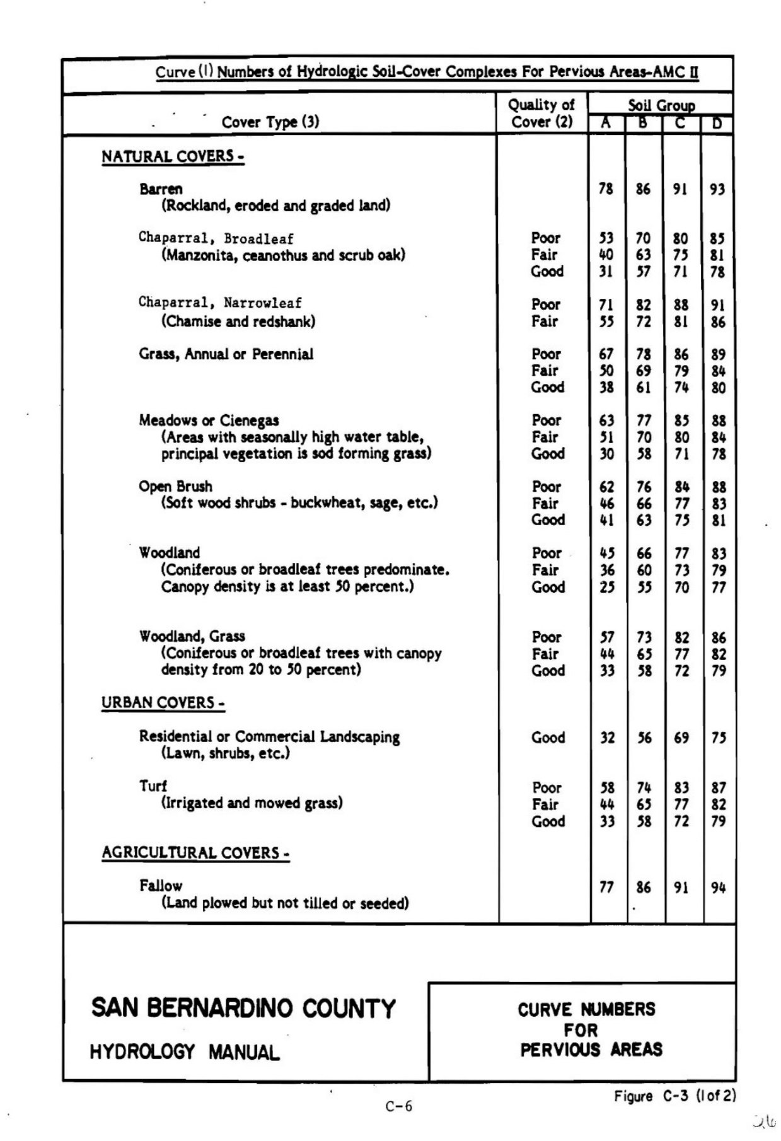
SBCHM Figure C-3; Curve Numbers for Pervious Areas

SBCHM Table C.1; Curve Number Relationships. Convert AMCII to AMCI
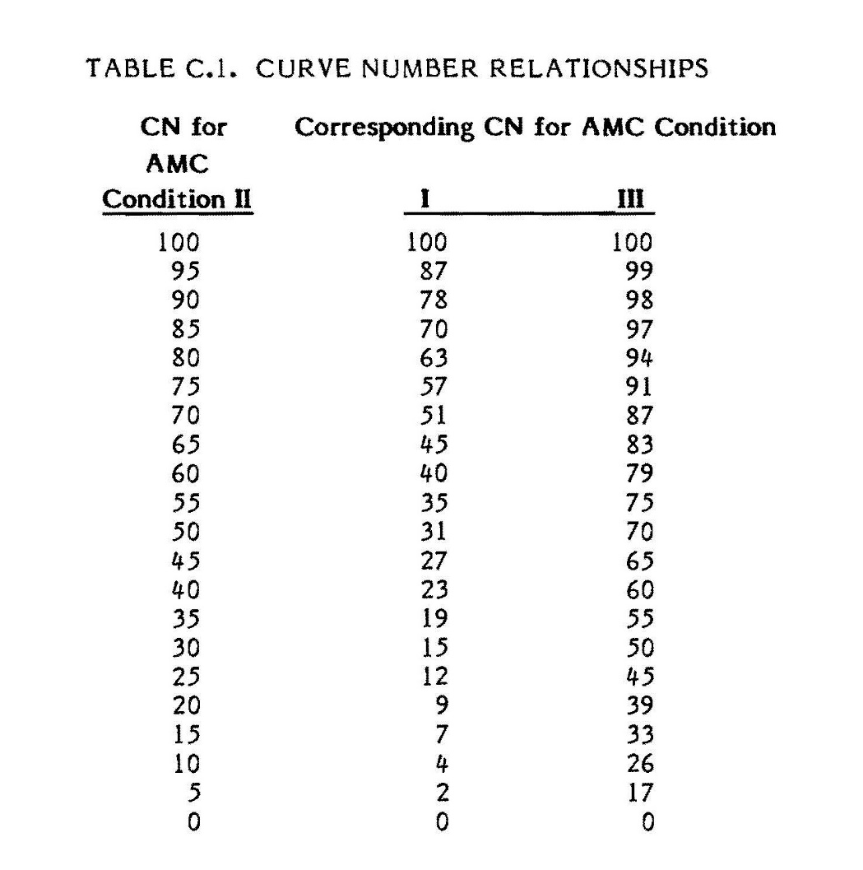

Hydromodification – Time of Concentration Form
Compute time of concentration for pre and post developed conditions for each DA
Drainage Area: |  |  |  | Click or tap here to enter text.
Variables | Pre-developed |  | Post-developed
Drainage Management Area (DMA) #: | Click or tap here to enter text. | Click or tap here to enter text. | Click or tap here to enter text. |  | Click or tap here to enter text.
1 Length of Drainage Management Area flowpath (ft) for specific condition  show on WQMP Exhibit | Click or tap here to enter text. | Click or tap here to enter text. | Click or tap here to enter text. |  | Click or tap here to enter text.
2 Change in elevation (ft) | Click or tap here to enter text. | Click or tap here to enter text. | Click or tap here to enter text. |  | Click or tap here to enter text.
3 Slope (ft/ft)  So = Item 2 / Item 1 | Click or tap here to enter text. | Click or tap here to enter text. | Click or tap here to enter text. |  | Click or tap here to enter text.
4 Land cover type  (Barren, Commercial, etc.) | Click or tap here to enter text. | Click or tap here to enter text. | Click or tap here to enter text. |  | Click or tap here to enter text.
5 Initial DMA Time of Concentration (min)  Figure D-1 Nomograph. Indicate with colored lines | Click or tap here to enter text. | Click or tap here to enter text. | Click or tap here to enter text. |  | Click or tap here to enter text.
6 Length of conveyance from DMA outlet to project site outlet (ft)  Lchannel: May be zero if DMA outlet is at project site outlet: | Click or tap here to enter text. | Click or tap here to enter text. | Click or tap here to enter text. |  | Click or tap here to enter text.
7 Cross-sectional area of channel (A) ft2 | Click or tap here to enter text. | Click or tap here to enter text. | Click or tap here to enter text. |  | Click or tap here to enter text.
8 Wetted perimeter of channel (P) ft | Click or tap here to enter text. | Click or tap here to enter text. | Click or tap here to enter text. |  | Click or tap here to enter text.
9 Manning’s roughness of channel bottom (n) | Click or tap here to enter text. | Click or tap here to enter text. | Click or tap here to enter text. |  | Click or tap here to enter text.
10 Channel flow velocity (ft/sec)  Vfps = (1.49 / Item 9) * (Item 7/Item 8)^0.67 * (Item 3)^0.5 | Click or tap here to enter text. | Click or tap here to enter text. | Click or tap here to enter text. |  | Click or tap here to enter text.
11 Travel time to outlet (min)  Tt = Item 6 / (Item 10 * 60) | Click or tap here to enter text. | Click or tap here to enter text. | Click or tap here to enter text. |  | Click or tap here to enter text.
12 Total time of concentration (min)  Tc = Item 5 + Item 11 | Click or tap here to enter text. | Click or tap here to enter text. | Click or tap here to enter text. |  | Click or tap here to enter text.
13 Pre-developed time of concentration (min):  Minimum of Item 12 pre-developed DMA |  |  |  |  |  | Click or tap here to enter text.
14 Post-developed time of concentration (min):  Minimum of Item 12 post-developed DMA |  |  |  |  |  | Click or tap here to enter text.
15 Additional time of concentration needed to meet requirement (min):  (Item 13 * 0.95) – Item 14 |  |  |  |  |  | Click or tap here to enter text.
Notes: Click or tap here to enter text.

SBCHM Figure D-1; Time of Concentration Nomograph for Subarea
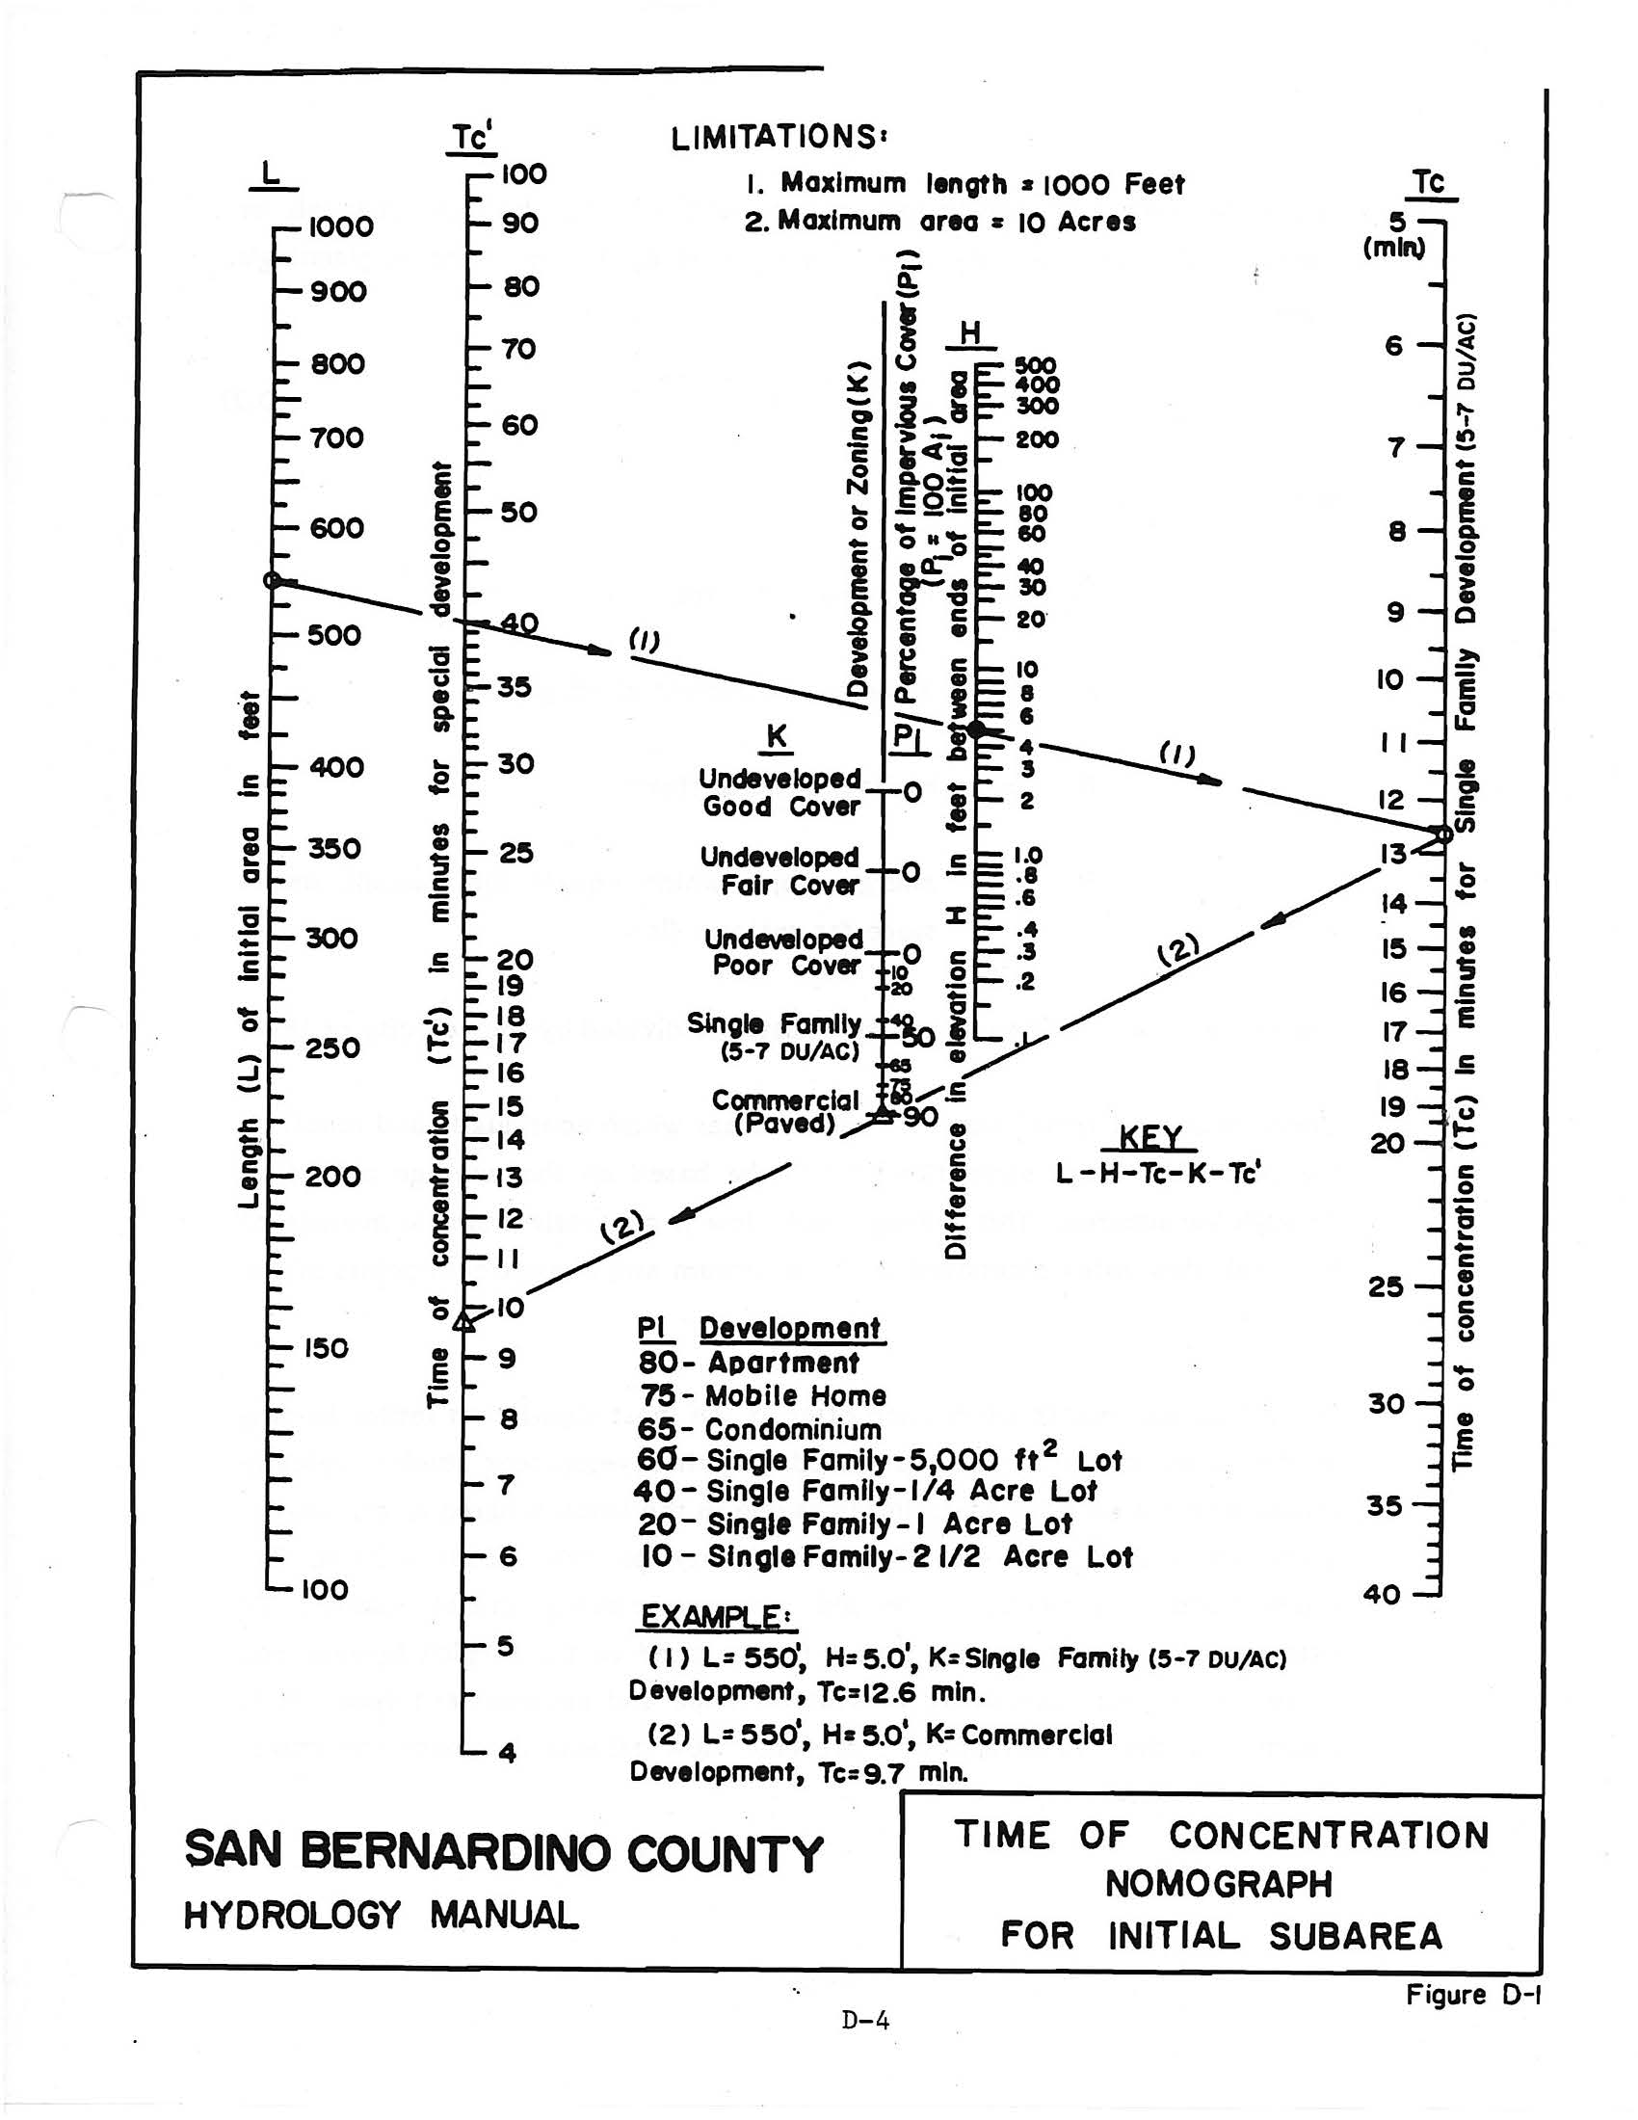
Provide colored lines as shown in the example provided

Hydromodification Assessment – Peak Runoff Form
Use additional forms if more than 3 DMA
Drainage Area: |  |  |  |  |  |  | Click or tap here to enter text.
Variables |  | Pre‐developed DA to Project Outlet |  |  |  | Post‐developed DA to Project Outlet
Drainage Management Area (DMA) #:
1 Rainfall Intensity for storm duration equal to time of concentration
peak = 10^(LOG rainfall 2yr-1hr ‐ 0.7 LOG DMA Tc/60)
2a Drainage Area of each DMA (ft²)
2b Drainage Area of each (acres)
3 Ratio of pervious area to total area
4 Pervious area infiltration rate (in/hr)
Use pervious area CN Figure C-3 and convert antecedent moisture condition from Table C.1: graph provided C-6
5 Maximum loss rate (in/hr)
Fm = Item 3 * Item 4
Use area‐weighted Fm from DMA with outlet at project site outlet, include upstream DMA
6 Peak Flow from DMA (cfs)
Qp = 0.9 * (Item 1 ‐ Item 5) * Item 2b
7 Time of concentration adjustment factor for other DMA to site discharge point Form 7.3 Item 12 DMA / Other DMA upstream of site discharge point (If ratio is greater than 1.0, then use maximum value of 1.0) | DMA A | n/a |  |  | n/a
 | DMA B |  | n/a |  |  |  |  | n/a
 | DMA C |  |  | n/a |  |  |  |  |  | n/a
8 Pre‐developed Qp at Tc for DMA A:
Qp = Item 6DMAA + [Item 6DMAB * (Item 1DMAA ‐ Item 5DMAB)/(Item 1DMAB ‐ Item 5DMAB)* Item 7DMAA/2] + [Item 6DMAC * (Item 1DMAA ‐ Item 5DMAC)/(Item 1DMAC ‐ Item 5DMAC)* Item 7DMAA/3]
9 Pre‐developed Qp at Tc for DMA B:
Qp = Item 6DMAB + [Item 6DMAA * (Item 1DMAB ‐ Item 5DMAA)/(Item 1DMAA ‐ Item 5DMAA)* Item 7DMAB/1] + [Item 6DMAC * (Item 1DMAB ‐ Item 5DMAC)/(Item 1DMAC ‐ Item 5DMAC)* Item 7DMAB/3]
10 Pre‐developed Qp at Tc for DMA C:
Qp = Item 6DMAC + [Item 6DMAA * (Item 1DMAC ‐ Item 5DMAA)/(Item 1DMAA ‐ Item 5DMAA)* Item 7DMAC/1] + [Item 6DMAB * (Item 1DMAC ‐ Item 5DMAB)/(Item 1DMAB‐ Item 5DMAB)* Item 7DMAC/2]
10 Peak runoff from pre‐developed condition confluence analysis (cfs):
Maximum of Item 8, 9, and 10 (including additional forms as needed)
11 Post‐developed Qp at Tc for DMA A: Same as Item 8 for post‐developed values
12 Post‐developed Qp at Tc for DMA B: Same as Item 9 for post‐developed values
13 Post‐developed Qp at Tc for DMA C: Same as Item 10 for post‐developed values
14 Peak runoff from post‐developed condition confluence analysis (cfs):
Maximum of Item 11, 12, and 13 (including additional forms as needed)
15 Peak runoff reduction needed to meet Hydromodification Requirement (cfs):
Qp‐hydro = (Item 14 * 0.95) – Item 10
Notes: Click or tap here to enter text.

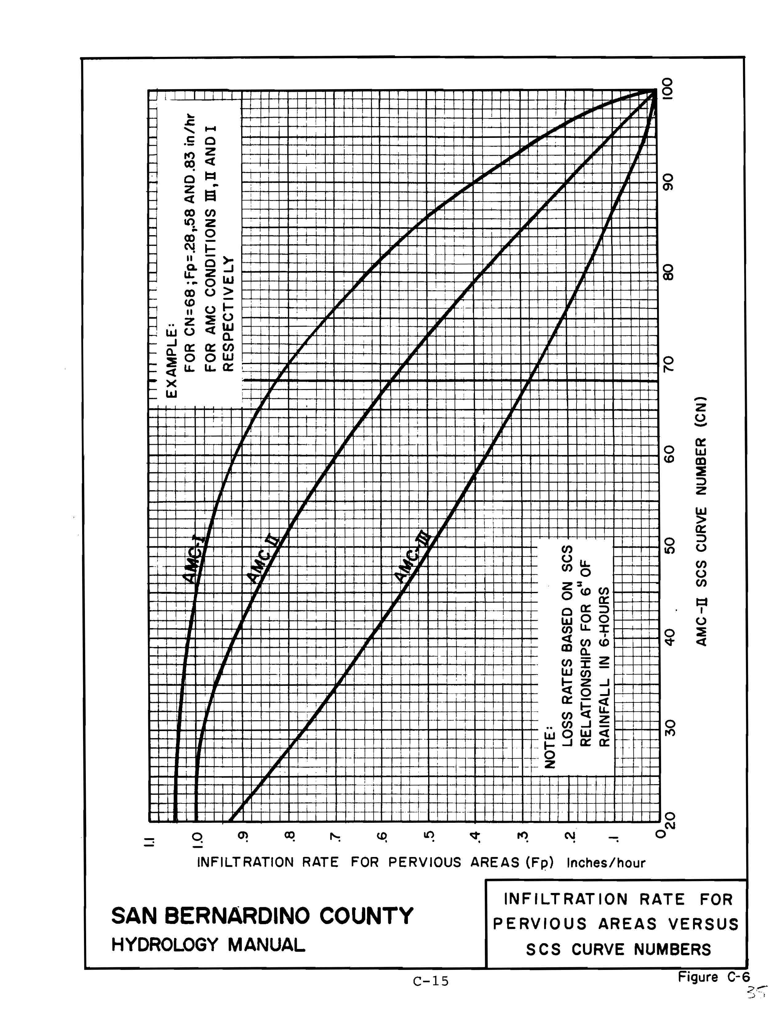

Hydromodification Management Summary Form
Drainage Area: |  | Click or tap here to enter text.
1 Volume reduction needed to meet DCV capture requirement (ft3):  (Section 6.1, Item 13 * 0.95) – (Section 6.1, Item 12) | Click or tap here to enter text.
2 On‐site retention with site design hydrologic source control, infiltration, and selected BMPs (ft3): | Click or tap here to enter text.
3 Remaining volume needed for DCV capture (ft3):  Item 1 – Item 2  If not “0”, evaluate options in Section 4.  Only after city written approval, any remaining DCV not captured on site shall be treated to the MEP applicable prior to city MS4 reception. | Click or tap here to enter text.

4 Time of Concentration needed to meet pre- and post- conditions:  (Section 6.2 Item 13) – (Section 6.2 Item 14) | Click or tap here to enter text.
5 Difference %  (Item 4 / Section 6.2 Item 13) | Click or tap here to enter text.
6 Engineer’s description on how methods, design and BMPs provided achievement in maintaining the Time of Concentration from pre- and post-conditions.
Click or tap here to enter text.

7 Peak Runoff needed to meet pre- and post- conditions:  (Section 6.3 Item 14) – (Section 6.3 Item 10) | Click or tap here to enter text.
8 Difference %  (Item 7 / Section 6.3 Item 10) | Click or tap here to enter text.
9 Engineer’s description on how methods, design and BMPs provided achievement in maintaining Peak Flow from pre- and post-conditions.

Click or tap here to enter text.

Project Conformance Summary

- Did right-of-way improvements exceed 5,000 square feet of new impervious surface? |  |  | Yes, it was given a Drainage Area and it’s required volume is added to project.  N/A
- Required Total DCV for all DAs (ft³):  Enter total(s) from all Drainage Areas in Section 4.1, Item 12 |  |  | Click or tap here to enter text.
- How much DCV retention was utilized in: (ft³): | Section 4.3.1 #9 |  |  |  | Click or tap here to enter text.
- How much DCV retention was utilized in: (ft³): | Section 4.3.2, #9 |  |  |  | Click or tap here to enter text.
- How much DCV retention was utilized in: (ft³): | Section 4.3.3, #7 |  |  |  | Click or tap here to enter text.
- How much DCV retention was utilized in: (ft³): | Total from Section 4.3.4, #4 |  |  |  | Click or tap here to enter text.
- How much DCV retention was utilized in: (ft³): | Section 5.4.1, #16 |  |  |  | Click or tap here to enter text.
- How much DCV retention was utilized in: (ft³): | Section 5.4.2, Underground Volume  (provide separate calc sheet) |  |  |  | Click or tap here to enter text.
 | Total from Section 5.4: |  |  |  | Click or tap here to enter text.
- Entire DCV was met by infiltration, bioretention, evapotranspiration, harvest & use methods? | Yes, Achieved Total DCV for all DAs (ft³): |  |  |  | Click or tap here to enter text.
 |  |  |  |  | Enter totals from Section 4 (item #3) and 5.4 (Item #4)
 | No Remaining DCV was treated by Flow-thru methods as shown in Section 5.5
- Pollutants of Concern addressed | Trash  Sediment  Oil/Grease  Pesticides |  |  |  | Metals  Toxic Compounds  Bacteria  Nutrients/Other
- Did project require Hydromodification Management? |  |  | Yes, Section 6 is provided or software calculations/data results are provided and highlighted, as required/stated in Section 6.  N/A, impervious surface is less than 1 acre
Engineer’s Summary Notes: |  | Date: |  | Click or tap here to enter text.
Click or tap here to enter text.

Source Control Selection

Source Control BMPs for Industrial/Commercial Sites
Select BMPs specific to site design and activities. Each selected shall be listed in the Operations and Maintenance (O&M) with site specific instructions. If project has an existing equivalent spill mitigation plan, a copy may be provided in the O&M. BMPs selected below are BMPs applicable to the project and do not supersede existing mitigation plans under previous environmental requirements. All BMPs selected shall be used interchangeably with Good Housekeeping Measures. Select and detail in the O&M accordingly.
BMP Type | Check one
BMP Type | Incl. | N/A
Employee Training
Quality Assurance & Record Keeping
SC-10 Non-Stormwater Discharges
SC-11 Spill Prevention, Control and Cleanup
SC-10 Non-Stormwater Discharges
- Interior floor drains
- Pools, spas, ponds, decorative fountains, and other water features
- Industrial processes (washing)
  - Outdoor storage of equipment or materials
  - Vehicle and equipment cleaning
  - Vehicle and equipment repair and maintenance
- Drain or wash water from boiler drain lines, condensate drain lines, rooftop equipment, drainage sumps, and other sources
SC-20 Vehicle and Equipment Fueling
SC-21 Vehicle and Equipment Cleaning
SC-22 Vehicle and Equipment Repair
SC-30 Outdoor Loading/Unloading
SC-31 Outdoor Liquid Container Storage
SC-32 Outdoor Equipment Operations
SC-33 Outdoor Storage of Raw Materials
SC-34 Waste Handling and Disposal (Trash Enclosure Detail, City Standards)
SC-40 Contaminated or Erodible Areas
SC-41 Building & Grounds Maintenance
SC-42 Building Repair and Construction
SC-43 Parking/Storage Area Maintenance
SC-44 Drainage System Maintenance

Treatment Control BMPs
The engineer shall provide procedures, and mechanisms of maintenance. Treatment BMPs shall include latitude/longitude location(s), dimensions, and cross-sectional view in the WQMP Exhibit. Details (including inlets, grates, filtering materials, etc.) shall be included.
Treatment structures (inlets, open channels, boxes, swales, strips, ditches, basins, etc.) must be inspected semi-annually at minimum, (during late summer and early fall), and cleaned as needed to remove all accumulated sediment/debris that fills 25% of the storage capacity. Smaller devices shall be inspected after each rain event.
Note: Treatment structures (basins, channels, planters) that are calculated for volume, retention, infiltration, etc., are required to be maintained (or redesigned) in order to maintain optimal function as designed by the engineer and calculated in this WQMP. The safety factor used in the calculations does not exempt regular maintenance, or the need for reconstruction when required. All such structures shall be described in the O&M Section, including but not limited to: design size (e.g., dimensional length, width, depth), capacity, infiltration/flow rate(s), vegetation density and type(s).

City of Barstow details | Incl. | Not Incl
SW-6: Parking Lot Slope-sided Bioretention, with underdrain
SW-6A: Parking Lot Slope-sided Bioretention, NO underdrain
SW-7: Parking Lot Bioretention Planter Box, with underdrain
SW-7A: Parking Lot Bioretention Planter Box, NO underdrain
SW-9: Bioretention Planter Box, NO Parking
SW-22: Overflow Structure with Beehive Grate
SW-22A: Overflow Structure Collar
SW-23: Overflow Structure with Square Grate

CASQA
TC-10: Infiltration Trench
TC-11: Infiltration Basin
TC-22 : Extended Detention Basin
TC-30 : Vegetated Swale
TC-31: Vegetated Buffer Strip
TC-32: Bioretention:

See City of Barstow

Not suitable for sites slopes greater than 20%

Manufactured or Engineer designed
- Provide Calculations, specifications, and information.
- In Exhibit only provide the size, model # designed for the project, or highlight circle, provide details, latitude/longitude of opening, inspection, test, monitoring port(s).
- Provide details.
- In O&M provide Owner with details for re-ordering or obtaining further information.
- Hydraulic and trash capture provided, not generally a stand-alone treatment.
- Vector/rodent control
- Include any soil improvements (engineered soil mixture, media soils).

Preparing Operation & Maintenance (O&M) Plan

An O&M template is available. Engineer may utilize another format and include:

- Name and address of the Project;
- Signing Engineer of Record;
- Signing financial responsible Owner of the property;
- 8x11 sized to scale of the Site Plan or WQMP Exhibit C showing the location(s) of the installed treatment system(s) and hydromodification control(s) (if any);
  - Underground systems shall include surface dimensions to view ports/inspection chambers, etc.
  - Surface BMPs shall show dimensions to length, width, and depth,
  - Cross section details of basin(s), swales, and rain gardens with the depth of the media, gravel, amended soils, and ponding areas.
  - Manufacture’s details and cross sections shall include model number(s), sizes, and any information needed to reorder replacement filters/materials (if any).
- Site specific maintenance instructions:
  - Ensuring the systems and hydromodification controls installed are properly operated and maintained for the life of the project.
  - Good Housekeeping Procedures that if not conducted will affect the optimal function of the designed BMP.
    - Template Form is provided for Good Housekeeping Measures:
(Tip: Source Control BMP Fact Sheets and Business Category Guide Sheets found in the CASQA BMP Handbooks are a good resource of information).
Form provides a column for future operators to use to conduct inspections or mark off activity.
    - Instructions for visual indications that the BMP requires maintenance or replacement.
    - Frequency and schedules for inspections, replacement of filters, and activities that protect the BMP.
  - Treatment Form shall be provided for all methods in which the DCV, Hydromodification and Treatment was conducted, and these methods retain and/or treat runoff.

For: Project Name |  | Address |  | City Approval Plan#:
NON-Structural “good housekeeping” source control bmps required
BMP Name/ Description Type | Responsible Party(ies) or those that will perform tasks |  | BMP Implementation |  | Inspection Frequency & Schedule | Inspection Use (Name/date)

For: Project Name |  | Address |  |  | City Approval Plan#:
BMP INSPECTION PROGRAM for

Treatment Control BMPs
One table for each BMP observation location.

Treatment BMPs are subject to regulatory inspection by local, and state jurisdictions.
# BMP Name/Type: |  |  |  |  |  | Inspection Use  (name,date)
BMP Function
(pre-treatment filter, infiltration, etc.):
Reference #:
(Detail name, page #, of attached reference)
Latitude:  (BMP observation location, e.g., inspection port, inlet opening, etc.) | 34. xxxxxx |  | Longitude: | -117.xxxxxx
Describe design:
(Structures, materials, design, slope ratios, surface coverings, such as 6” deep 3”dia gravel)
Dimensions (ft) Top/Surface: | Length x Width |  | Bottom: | Length x Width
Capacity(ft³) / Size: |  |  | Depth(ft):
Manufacturer:
(Website/Contact Info, or constructed on site fill all dimensions above)
Model #:
(if replacement parts required)
Inspection Type:  (Check all that apply) | Visual |  | Other: _
Inspection Frequency & Schedule(s)  (Check all that apply) | After Rain  Monthly  Quarterly |  | Biannually (twice a year)  Annually  Other:
Engineer’s Notes: | (Describe visual conditions indicating potential BMP failure, potential risks or warning indications.)
Additional Notes: | (e.g. Owner’s/Inspectors notes of contracted maintenance, inspection findings, incident observations, etc.)

WQMP & Exhibits Submittal Checklists

WQMP DOCUMENT CHECKLIST

All Regulated WQMP submittals are reviewed to include (but not limited to) the following:
- This Regulated WQMP Template completely filled with no blanks (state “0” or “N/A” for non-applicable topics).
- Designing Engineer’s and Land-Owner’s wet-signatures, stamp, and date will be required on final approved copy.
- Provide supporting data as Attachments requested in Sections 1 -3, and update as new information is obtained.
  - For example: Web-soil Survey data may be used during preliminary design, however, an engineer signed Geotechnical Report and Infiltration Study will supersede in calculations provided.
- Section 4.3.4 shall provide Site Design Measures for roof run-off and/or small area non-polluted water infiltration. Rare circumstances will this Section be allowed to be omitted. Any amount satisfies this requirement.
- Section 7 Conformance Summary shall include an engineer’s summary of the project’s design concepts and compliant achievements.
- Prepare and provide for review Exhibits. Once approved, the following Exhibits will be copied into the Operations and Maintenance (O&M) Plan, and the Covenant and Agreement Recording:
  - Exhibit A – Legal Description & Exhibit B – Legal Description Map
    - Projects that do not intend to change the existing Legal Description of the land Title Deed may provide a copy of the current Legal Description for verification as “Exhibit A” with copy of Tract, Parcel Map as “Exhibit B”. These will be required when the Covenant & Agreement are submitted for review.
  - Exhibit C – WQMP Exhibit Plan. See Section 10.2 below
  - Exhibit D.1 Non-Structural BMPs. The WQMP Packet provides this Exhibit D.1 template as a separate document that may be easier to modify than the form attached to this template. Exhibit D.1 shall include CLEAR and DETAILED descriptions of Good-Housekeeping Practices
    - Under the Implementations column, the designing engineer is strongly encouraged to list and describe workplace Good-Housekeeping Practices regarding surfaces, inlets, and drainage leading to the treatment BMP(s). This form is intended to be a long-term checklist (Inspection Form) written by the signing engineer for site managers and employees to follow as a guide that will preserve the design, longevity, and function of the designed treatment BMP(s). The engineer is encouraged to list onsite/surface or adjacent restrictions, and visual indications, and/or “DO NOT…” s that could potentially hinder the function and design of the treatment BMP.
    - Under the Schedule column state a minimum timeline or situation that triggers an onsite inspection (e.g., “after a rain event”, Annually, no later than August”. Vague scheduling such as “Periodically”, or “As needed” will not be allowed.
  - Exhibit D.2 Structural BMPs. The WQMP Packet provides this Exhibit D.2 template as a separate document that may be easier to copy for multiple structures than using the form in Section 9 of this template. Exhibit D.2 shall include one form for each pre-treatment and treatment BMP. The Latitude & Longitude shall indicate the servicing opening if underground, or central for surface basins.
    - Surface infiltration basins shall include dimensions, depths, slopes, surface types, cross-section detail(s), and in the bottom Notes include:
“NO STANDING WATER (PONDING) IS ALLOWED AFTER 72 HOURS AFTER A RAIN EVENT. CRACKED SOILS AND SLOW INFILTRATION INDICATE THE BASIN REQUIRES MAINTENANCE AND SHALL BE CONDUCTED PRIOR TO NEXT RAIN EVENT.”

- A WQMP Drainage Plan (24x36) is different in that it accompanies the WQMP document (duplicated from the Grading Plan) and clarifies multiple drainage areas that correlate with the WQMP design. The WQMP Drainage Plan may reference WQMP Forms or page #. A WQMP Drainage Plan is necessary for complex sites and welcome for all projects, but not always necessary if the Grading Plan can clearly identify the following without becoming convoluted. A Drainage Area Plan may be requested by the plan checker.
  - Identify Street Names and major intersections.
  - Identify distance from Mojave River and city storm-conveyance systems.
  - Describe surrounding areas, such as “Vacant,” “Paved Industrial/Commercial.”
  - Site Plan Scale
  - Topography.
    - Directions of flow.
    - Label known flow patterns, such as Blue lines, hydrology issues/concerns.
  - Existing and Proposed Elevations.
  - Identify existing and proposed site features, such as sidewalks, paved parking, outdoor work areas, material storage areas, etc.
    - Label entrances, delivery doors, pick-up/delivery routes
    - Trash enclosures (existing and proposed)
    - Storage areas (label “Covered”, “enclosed”, “open”)
  - Proposed location(s) of materials/equipment to be stored.
  - Identify landscaped areas. Landscaped areas to be used as a BMP shall provide the necessary information in Exhibit D.2.
    - Show by symbol trees used in the tree credit.
  - Location of existing and proposed public and private storm drainage facilities (i.e., storm drains, channels, basins, etc.) include outlets up gradient that will affect project.
  - Identify outlet location and distance.
  - Identify locations of run-on or receiving waters.
  - Identify location points of run-off or exiting flows that are proposed to leave site.
  - Clearly identify and delineate “Drainage Management Areas” by following grade breaks/roof ridgelines, etc., that will drain to the proposed BMP element. Calculate total area including pervious and impervious surfaces, and any off-site areas that flow to this point.
  - Label Drainage Areas to match the WQMP forms and calculations provided within.
    - For each Drainage Management Area list flow and volumes.
Whereas Exhibit C purpose is to accompany Exhibits D.1 and D.2.

PREPARING WQMP Exhibit - EXHIBIT C (8x11)
Exhibit C is the WQMP Exhibit Plan 8x11 sized post-construction site plan MUST BE LEGIBALE!
The 8x11 sized WQMP Exhibit is intended to be recorded in the Covenant & Agreement and used for referencing locations and dimensions of the finished site and those BMPs listed in Exhibits D.1 and D.2.

Generally, the Exhibit Plan is the Drainage or Grading Plan with small text turned off and symbols to indicate BMPs to provide a cleaner (less cluttered) version. More than one sheet may be necessary in addition to the following:
  - North Arrow
  - Site Address and Street Name
  - Site Entrance (Driveway)
  - Surface flow directional arrows.
  - Storm drains, inlets, Ribbon Gutters,
  - Symbol or point to location of roof downspouts and direction of flow.
  - Include details and specifications of Post-Construction BMP structures.
    - Cross section details with dimensions (surface locations, surface openings, slopes, top and toe dimensions
  - Proposed site features, such as:
    - Roof edges, Sidewalks, Paved parking, Driveways, Gates/Fences/Walls, etc.
    - Label entrances, delivery doors, pick-up/delivery routes.
    - Trash enclosures.
    - Storage areas (label “Covered”, “enclosed”, “open”)
    - Materials/equipment storage areas,
    - Outdoor work areas,
    - Identify landscaped areas.
    - Hatches for surface area types (gravels, grass, swales, etc.)
    - Site Design Measures that require a cross section detail are:
    - Vegetated Swales
    - Soil Quality Amendments with Soil mix ratio.

- Include as part of the document, attached to the end:
  - copy of the Demolition Area (if applicable; Section 1.1, #18),
  - copy(ies) all sheets of the Grading/Site Plan(s) at 8x11 sized sheets,
  - copy(ies) of the Erosion Control Plan at 8x11 sized sheets, and
  - 8x11 copy(ies) of the Landscaping Plans (if available).

Provided as separate Documents for Review Checklist

An Operations & Maintenance Plan/Program (O&M).
See O&M Instructions and Template, provided as a separate document.
- Any format familiar to the landowner is welcome as long as the document meets water quality standards of the city’s MS4 NPDES permit. A general template is provided as a separate document for your convenience, however,
  - Existing (e.g., where the project is an addition) shall provide the existing SCPP/SWPPP with the addition(s), whereas.
  - A new O&M may be combined or called SCPP/SWPPP if the project is subject to the Industrial General Permit,
- Approved Exhibits C, D.1, and D.2 will be included in the O&M.
- Provide CASQA BMP Factsheets relevant and site specific in accordance to Section 9 selections per final design. Handbooks will include:
  - the Development (latest edition 2021), and
  - the Industrial-Commercial (latest edition 2019) BMPs.
    - BMPs from the Construction and Municipal BMP Handbooks are rarely applicable to New and Re-development projects.
- Provide manufacture’s specifications and Owner’s Manual Guidelines

Covenant and Agreement Recording
See Recording Instructions and template provided as a separate document.
- Avoid redundancy and provide after approval of Lan Ownership, Tract Maps, is completed.
- Submit when requested by city and when site approval is near.
--end of WQMP Guidance & Template

2013-0001-DWQ Attachment F #12.
For Google Earth: under Tools, Options, 3D View, Show Lat/Long; the Decimal Degrees circle-box is highlighted.
Runoff from the entire project, consisting of all existing, new, and/or replaced impervious surfaces, must be included to the extent feasible.
Only runoff from the new and/or replaced impervious surface of the project must be included.
City may request GIP site documents. “Preliminary/Draft” accepted in lieu of this WQMP Template. City review does not indicate GIP compliance or approval. Review confirms that the document(s) provides site-specific calculations with sufficient evidence that methods used meet or exceed LID standards in regards to pollutants of concern, storage/handling, storm and run-off exposure, treatment and proper disposal, etc. Final/Certified PRDs and GIP WDID# will be required. Where the site is a re-development with an existing No Exposure Certification (NEC), per the GIP: dischargers with No Exposure Certification (NEC) coverage that anticipate a significant change(s) in the facility layout leading to exposure shall register for permit coverage prior to the anticipated changes.
SFR of 4 units or less shall provide SFR WQMP Template for each. Omit O&M and Recording Sections. https://library.municode.com/ca/barstow/codes/code_of_ordinances?nodeId=COOR_TIT18PLSU_CH18.06SUFIMOPAENFIMA
Per San Bernardino County 2010-0412 Addendum IV to replace Section C of the Hydrology Manual (1986).
At the earliest planning stages, Regulated Projects are required to assess and evaluate how site conditions, such as soils, vegetation, and flow paths, will influence the placement of buildings and paved surfaces. The evaluation will be used to meet the goals of capturing and treating runoff and assuring these goals are incorporated into the project design.
This includes all offsite activities (e.g., road improvements, utility connection requiring excavation, and/or fill/borrow locations within city limits, etc.) as part of this project. This area will be the same as shown in the Erosion Control Plans. Provide Preliminary Erosion Control Plans as Attachment VI.
If 3.2.2 Item 12 results in an increase of more than 50% of Item 3.2.1, Item 8, AND this project is a “Redevelopment”: runoff from the entire project, consisting of all existing, new, and/or replaced impervious surfaces, must be included to the extent feasible. Item 3.2 Item 3 shall include entire site and new BMPs shall be selected and sized accordingly.
Address Hydromodification Management early in design. Provide hydrology calculations supporting design and select BMPs that support the flow rates.
Per San Bernardino County 2010-0412 Addendum II to replace outdated isohytal maps with NOAA Atlas 14.
CoB §19.08.070 & 080 for Industrial/Commercial Sites: 1 tree per every 30 linear ft of street & one tree per ten parking spaces. Tree credit per Phase II Post Construction Calculator. Calculation per SBC WQMP Guide.
E.12.e.ii.c.2
CASQA New Dev/Redv., Appendices D
Per sbcounty: http://www.sbcounty.gov/dpw/floodcontrol/pdf/2 0100412_addendum.pdf, use https://websoilsurvey.nrcs.usda.gov/app/WebSoilSurvey.aspx however engineer should consider site-specific geotechnical studies
use Tables provided in Section 7.1.1, & 7.1.2 to select appropriate CN from Figure C-3 of the SB County Hydrology Manual, convert CN Condition II to AMC Condition I, as shown in Table C.1 of the SBCounty Hydrology Manual
Per San Bernardino Hydrology Manual C.6.2 (C.3).
(n) common surfaces with averages: Asphalt=0.016, concrete=0.012, earth smooth=0.022, low grass=0.25, earth w/ gravel=0.035, earth heavy landscaped/large jagged rock=0.050-0.1.
San Bernardino Hydrology Manual D.3 (D.2).
Fm Estimation per San Bernardino Hydrology Manual C.6.5 (C.7).
Q Peak Flow rate Formula per San Bernardino County Hydrology Manual D.6 (D.4)

