
Engineering Department
Planning Department &
Public Works Departments

single family residential
Water quality management plan TEMPLATE

Tract/Subdivision projects of five or more parcels within the same tributary area require a Regulated WQMP Template.

Dear City of Barstow Home Builder,
CONGRATULATIONS! Building a new home or remodeling an existing home is exciting! There are so many fun decisions to make. The City of Barstow wants you to know that we are excited that you are choosing to be part of our community. Barstow is a GREAT place to live. Our staff is here to assist you in any way we can as you move forward to obtain the proper permits for your new home or renovations.
As you are aware, there are a few requirements the City of Barstow must enforce for both your safety, and the safety and well-being of others. These are commonly known as Building Codes and Municipal Codes, and Standards. Our staff will assist you, your developer, your contractor and builder with these during the Plan Review process.
Additionally, the City of Barstow is required by the Phase II Small Municipal Separate Storm Sewer Systems (MS4) Permit under the National Pollutant Discharge System (NPDES) and federal Clean Water Act (CWA) program issued throughout California and the U.S. to apply water quality management practices to all new development projects that meet a certain criterion. The City of Barstow has prepared this Single Family Residential - Water Quality Management Plan (SFR-WQMP) Template to simplify this requirement.
Not all projects are the same, just as your design choices are not the same as everyone else's. Low Impact Development (LID) Standards, Drought Tolerant Landscape Design, Bioretention, Xeriscape Irrigation, and Smart Sprinkler Technology are concept(s) well-established as sustainability methods throughout the United States, including arid regions such as ours. Please feel free to search (internet, Pinterest, etc.). The City of Barstow welcomes your design ideas as long as they meet the Phase II MS4 permit, local, state and federal laws. The city may or may not accept design methods used by other cities, counties, areas, but is willing to review, discuss, and approve such methods with proven efficiency, effectiveness, and applicability to your development, Zoning Area, and City of Barstow’s Standards.

Sincerely,
City of Barstow

SFR-WQMP Owner acknowledgement

The Owner is responsible for the implementation of the approved provisions of this plan.

“I hereby understand approval of this Single-Family Residential Water Quality Management Plan includes conditions and that failure to comply with those conditions written within this document will result in revocation of the project review and approval.

I am aware that any changes to size, type, or material may significantly change the impacts of water quality and it is my responsibly to bring these changes to the attention of the plan checker as soon as possible, and prior to final approval.

I am also aware that Water Quality Management extends to responsible and appropriate applications of substances that affect run-off. I am aware of applicable measures to reduce pollutant discharge when using and applying: fertilizers, pesticides, outdoor paint, irrigation applications, outdoor storage and equipment use, maintaining pet-waste, vehicle washing and maintenance activities, pool/spa maintenance activities, etc.

Land-Owner Name (Printed)  As it appears on the Current Deed |  | Project Address
Owner Signature (wet-signed) |  | Date

  - How to Use this Template
This template was created in Microsoft Word. Editing is best using Microsoft Word 98 or later version, but any compatible program will be accepted for the WQMP Review process. Final submittals shall comply with City’s approved format.
To begin editing, SAVE and RENAME this file to your computer.
This template has different elements and text colors described below.
- Tab to complete"Click here to enter text.."
- Blue text includes instruction and notes.
- Underlined text includes Hyperlink or Title.
Prior to submitting the WQMP for City review, add all necessary figures and attachments.
No permits (building / grading) shall be issued without final approval of WQMP qualifying projects.

  - What to Submit As Part of This Document
- Page ii SFR-WQMP Owner acknowledgement sheet Wet-Signed and dated by Owner of the final copy after all revisions are completed and design approved by the city.

- This template filled (completed with no blanks), and the attachments described below:
  - Each revision to the Grading Plan will require revisions to this template to match the current designs.

- Provide as part of this template a SFR WQMP Exhibit Plan.
  - See Section 5 for information and Checklist for items to be shown in the Exhibit.
  - Include dimensions to areas provided in Section 2.2.
  - Include callout, symbol(s), and/or hatching(s) of designs and surfaces selected in Section 3.

- Provide as an Attachment to this document:
  - Copy(ies) of most current Grading/Site Plan(s) that correlate to the design described within this template, and
  - An Erosion Control Plan. See Section 6 for small project example. The example is for reference only. The Erosion Control Plan shall include the City’s General Erosion Control Notes and site-specific Best Management Practices (BMPs) for the duration of the project’s completion.

TEMPLATE NEXT PAGE

Project Information
Fill the entire table.
Additional information or notes regarding items listed can be explained in Item #10.
- Owner Name: | Click here to enter text.
Mailing Address: | Click here to enter text.
Telephone: | Click here to enter text.
Email: | Click here to enter text.
- Project Address: | Click here to enter text.
- Assessor Parcel Number(s): | Click here to enter text.
- CUP / Permit ID #: | Click here to enter text.
- Zoning: | ER: 2.5 acres  LDR; 1 – 2.5 acres  SFR; 4,500 Square Feet (minimum)  MD; 6,000 Square Feet  Other:Click here to enter text.
- Builder’s Name:  Contractor’s Lic. Number: | Click here to enter text.
Check Project type:
- New Single-Family Residential Development: No existing structure on site.

- Redevelopment: Existing structure to remain, and additional structure or impervious surface(s) being added, including “Second Units” as described in §19.10.070.

- Redevelopment with Demolition: Existing impervious structure, or surface (paving), or part of an existing structure/surface will be removed, and new structure (or impervious surface) is being added.

- Other, describe: Click here to enter text.

Project Description
Fill the entire table.
Do not leave blanks. Use “0” for zero, or “N/A” for non-applicable.
- Total Property (Lot) Size: | Lot Size | Square Feet
- Total Area Disturbed: | Area Dist | Square Feet

Existing impervious conditions
- Roof (edge to edge) total | Roof | Square Feet
- Driveway | Dway | Square Feet
- Walkway | Wway | Square Feet
- Patios/Porches | Patios | Square Feet
- Other roofed areas: Click here to enter text. | XRoof | Square Feet
- Other paved areas: Click here to enter text. | Paved | Square Feet
- Gravel area (ONLY if plastic underlined. Gravel over native soils is not impervious) | Gravl | Square Feet
- Total (current) Impervious Area | TOTAL | Square Feet
Describe existing conditions (i.e., low growing weeds, dirt, graded, established landscape, ect.): Briefly describe

proposed (after construction) Impervious areas
- Roof (edge to edge) Total(s) | New Roof | Square Feet
- Driveway(s) | New Dway | Square Feet
- Walkway(s) | New Wway | Square Feet
- Patios/Porches(s) | New Patio | Square Feet
- Other roofed areas:Click here to enter text. | New Roofs. | Square Feet
- Other paved areas: Click here to enter text. | New Paved | Square Feet
- Gravel area (ONLY if plastic underlined. Gravel over native soils is not impervious) | New Gravel | Square Feet
- Total Impervious Area  (entire site after construction) | New TOTAL | Square Feet
- Percent of property impervious:  (Item #28 / Item #11) x 100 = | Percent | %
- Describe new conditions (i.e., describe landscaping, gravel, grass, surface types, etc.): Briefly describe

Project Designs
Select which Rooftop Area Disconnection type(s) your project will be using.

Roof Area Disconnection
Select: “A” or “B”, or a combination of " BOTH" may be selected. Indicate below and show location(s) of downspout(s) in Landscape Plan.
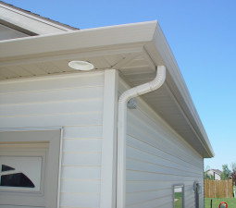 |  |  | 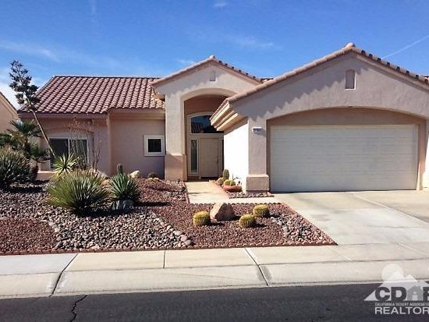
A: Rain from roof will be captured by a matching Roof Drain and Downspout (adequately sized) that will extend a minimum of 2 feet away from structure; leading rain from roof into a landscaped area (Hydrozone) a minimum of 10% of the roof area. |  |  | B: Rain from roof will form a dripline. The dripline will be landscaped or if the dripline shall fall on impervious surface (such as driveway, walkways, patios, etc.) the impervious surface will slope slightly so that it goes to pervious or landscaped area(s), and not out to the street directly.
List the square foot area of roof going to each Downspout and/or Dripline. List by # and show on Landscaping Plan
Downspout “A” or Dripline “B” | Roof Area  Sq. Ft | Hydrozone,  Receiving Surface
Downspout “A” or Dripline “B” | Roof Area  Sq. Ft | Describe Receiving Surface Type  ("Grass", "gravel", "Rain-Garden", etc.") |  | Area
"A" or "B" | Area Sq. Ft | Click here to enter text. |  | Area receiving Sq. Ft
"A" or "B" | Area Sq. Ft | Click here to enter text. |  | Area receiving Sq. Ft
"A" or "B" | Area Sq. Ft | Click here to enter text. |  | Area receiving Sq. Ft
"A" or "B" | Area Sq. Ft | Click here to enter text. |  | Area receiving Sq. Ft
"A" or "B" | Area Sq. Ft | Click here to enter text. |  | Area receiving Sq. Ft
"A" or "B" | Area Sq. Ft | Click here to enter text. |  | Area receiving Sq. Ft
Total Roof  (Matches #21) | Area.Sq. Ft |  |  | Total: Area Sq. Ft

Select any of the following Low Impact Development (LID) Example methods to reduce rain run-off.

In other words:
How is your home using rain as a resource:
- Will it mitigate to water plants, and soak into the ground,
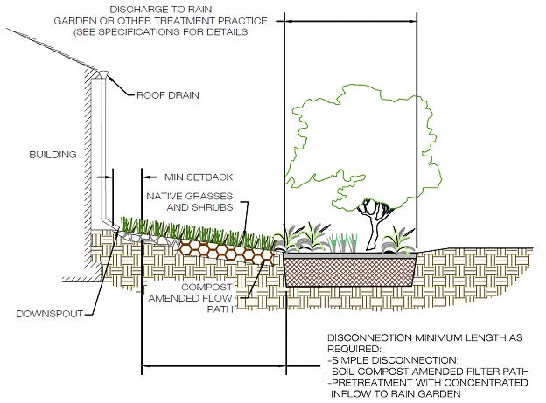

Such as shown in this:
Downspout to Rain Garden

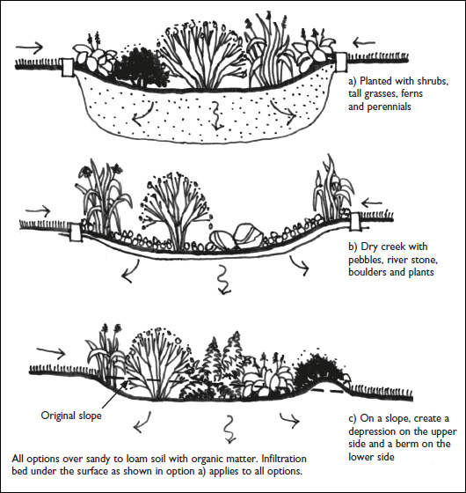

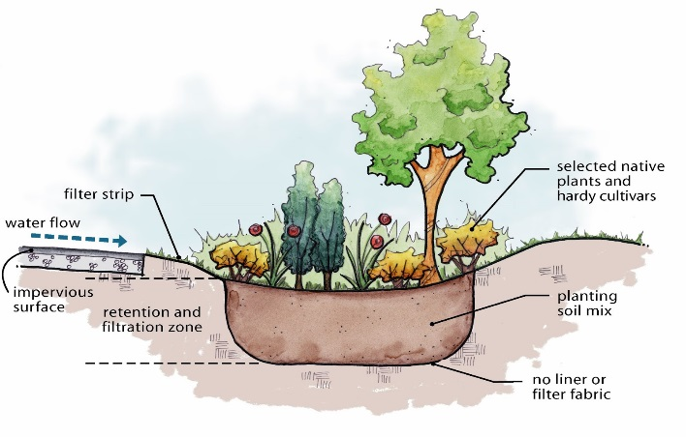
Rain Garden Details

…continue more examples next page

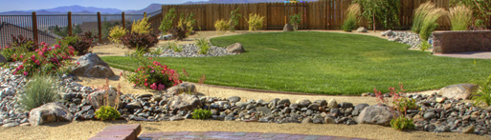
Rain Garden depression with grass, rather than a cluster of plants
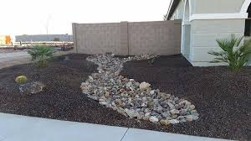
- Or will it mitigate thru the property but NOT create ponding that will stay longer than 48 hours (avoiding stagnate-mosquito breeding ground), AND will infiltrate as much as possible and leave the site without carrying a bunch of dirt/mud with it to the city streets?

Such as this: River Rock Swale;
slight depression will retain rain runoff and prevent the rocks from washing -out from the property.

- Or, have you found a different, or better approach? Tell us!

The city of Barstow has to show that one or more of the following Site Design Measures were incorporated. Please select as many that apply to your design in Section 3.3

Select all that apply
Check Box is used in design and fill in Area (Square Feet) and Depth (Feet).
Check | Area  Sq. Ft | Average  Depth Ft | Site Design Measure
 | Area | Ft | Soil Quality Improvement and Maintenance - improvement and maintenance of soil through soil amendments and creation of microbial community;  Soil amendments are sometimes beneficial to landscape plantings. If used, they should be added before planting. Additionally, Soil Alkalinity in the High Desert is between pH 7.5 – 9.0. A pH of 7.0 is neutral, although most plants grow well in pHs between 6.0 and 7.5. Soils tests/determination by a professional landscaper is useful to determine in the soil needs amendments for a successful landscape environment. Depth should be minimum of tree root ball.  Describe: Click here to enter text.
 | Area | Ft | Tree Planting and Preservation - planting and preservation of healthy, established trees that include both evergreens and deciduous,  Refer to City of Barstow approved Plant List for desert-drought tolerant trees and planting requirements. A limited species of trees is allowed on the street right-of-way. Owner shall select type and location best suited when the tree is at maturity, including trimming requirements.  Describe: Click here to enter text.
 | Area | Ft | Porous Stabilized Surfaces/Pavement - allows runoff to pass through it, thereby reducing the runoff from a site and surrounding areas and filtering pollutants;  Gravel surfaces with plastic underlining (for weed control) is not considered porous. Areas with plastic underlining are to be added as Impervious Area in Item #27.  Describe: Click here to enter text.
…Continue next page

…continued from previous page
Check | Area  Sq. Ft | Average  Depth Ft | Site Design Measure
 | Area | Ft | Vegetated Swales - a vegetated, open-channel management practice designed specifically to treat and attenuate storm water runoff;  Grading Plan/Landscape Plans will show where rain flows are diverted away from structure. Owner may create a vegetated, or rock-lined swale, or combination of both (commonly known as a Dry-Creek, or Grass-Swale used to control flows away from home, or from backyard to front yard to avoid flooding).  Describe: Click here to enter text.
 | Area | Ft | Rain Garden - a vegetated, open retention design specifically to capture sheet rain flow into an area to infiltrate.;  Rain Gardens may be grass lawn or cluster mixed drought tolerant vegetation and trees. Soils study to determine proper infiltration rate is required. Grass shall not exceed 30% of entire landscape area (up to a maximum of 900 square feet)  Describe: Click here to enter text.
 | Area | Ft | Other:  Examples may include: Efficient Irrigation Controls with sensors/timer, Hill-side Landscaping, etc..  Describe: Click here to enter text.

Information for residents
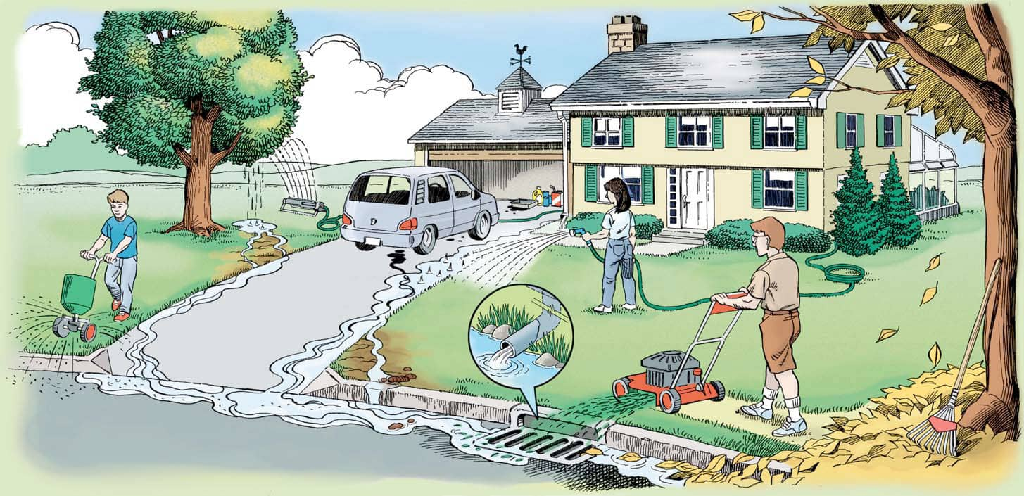
How to Limit Urban Run-Off
Urban run-off is what happens when water flows over impermeable surfaces, such as parking lots, streets and rooftops. Oil and gas from vehicles can leak onto roads and parking lots. Fertilizers and pesticides, if not applied properly, can wash off lawns.
Pet waste, if not properly disposed of, can enter storm drains that lead to wetlands, streams or rivers. As water flows over these surfaces the water picks up dirt and dust, rubber and metal deposits from tire wear, antifreeze and engine oil that has dripped onto the pavement, pesticides and fertilizers, and discarded cups, plastic bags, cigarette butts, pet waste,
TIPS:
Landscape with Nature - Consider Xeriscape and use of native-plants. Native plants are adapted to the local climate and pests. Xeriscape can limit chemical applications to lawns and gardens and reduce irrigation run-off.

Vehicle Washing - Try not to wash your vehicles where the water with grease and fluids from your car, soap, wax and cleaning products will run down the street and curb.
Properly store and dispose of all chemicals - If chemicals are needed around the home, they should be stored properly to prevent leaks and access by children. FREE Disposal of all household chemicals is offered every Saturday at the Household Hazardous Waste Bin, 900 South Ave. "H" in Barstow.

Provide SFR WQMP Exhibit plan
Standard sized submittal plans shall be scaled down and attached to this document
Exhibit CHECKLIST
Ensure the following are shown on 24” x 36” Plan View, or approved size of Grading Plan Submitted.
- Vicinity Map (birds-eye view) how the house/addition sits on the property.
  - Identify Street Names
  - North arrow

- Site Plan Scale
- Topography.
  - Label known flow patterns, such as direction of flows.
  - Is there any neighboring site that looks like it may run-on to your site? Or your site to them? Show and discuss this issue with the city.
  - Existing and proposed elevations.
  - Describe surrounding areas, such as “Vacant,” “Paved”, fencing, walls, etc.

- Identify existing and proposed site features, such as:
  - Roof ridges and area going to dripline or downspout,
  - Walkways, paved areas, gates

- Identify landscaped areas. Landscaped areas to be used as a Rain Gardens, dissipation devices, flow diversions shall provide the necessary information as described in this template.
  - Reference plants and show irrigation methods.
  - Callout and list areas of surface covering, such as gravel, grass
  - Show area and depth of Rain Gardens,
  - Callout the area and depth of replaced native soil with amended soil in/around Rain Gardens, Tree-Wells, etc.

Provide Copy of Erosion Control Plan:

All construction projects regardless of size (including those projects not large enough to be subject to the State’s Construction General Permit) are required by the City of Barstow to prepare and submit an Erosion Control Plan prior to the issuance of a building or grading permit. This plan is generally submitted as part of the Grading and Site Plans. This SFR Template requires copies to be provided as attachments to this document.
Erosion Control Plans shall include the City’s General Erosion Control Notes (provided as a separate document) and shall callout Good-Housekeeping Practices and Best Management Practices (BMPs) that will best suit the construction activities, site conditions, and any weather/non-weather potential hazards that may cause erosion, sediment travel and dust nuisance throughout the duration of the project’s disturbed areas.
Erosion Control Plan CHECKLIST
- Title Plan: EROSION CONTROL PLAN
- Include City’s GENERAL EROSION CONTROL PLAN NOTES (Provided as a separate sheet)
- Contact Information: Name(s), Company Name(s), Title(s), Address(es), Phone Number(s) for the following:
  - Owner / Legal Responsible Person
  - 24 Hour Emergency Construction Site Contact
  - Site address, APN, location description, and decimal Lat./Long.
- North arrow
- Site Plan Scale
- Topography (existing and proposed contours).
  - Label known flow patterns, such as direction of flows.
  - Proposed surface covers indicated by hatching (e.g., concrete, landscape, gravel, native or to remain undeveloped, etc.)
- Is there any neighboring site that looks like it may run-on to your site? Or your site to them?
  - Show and discuss this issue with the city.
  - Describe surrounding areas, such as “Vacant,” “Paved”, fencing, walls, etc.
- Existing and proposed elevations.
- Estimated Construction Start and End Dates (or estimated duration)
- Provide and fill the following table:
AREA BY TYPE | AREA (SQ. FT)
TOTAL PROPERTY
TOTAL DISTURBANCE
TOTAL PROPOSED IMPERVIOUS
- Location(s) of construction activities, including but not limited to, equipment parking, underground trenching for utilities, stockpile storage, laydown/storage areas, construction entrance, etc.
  - See Erosion Construction Plan Example below.
  - Address all 10 steps of Example below (minimum)

Erosion Control Plan Example
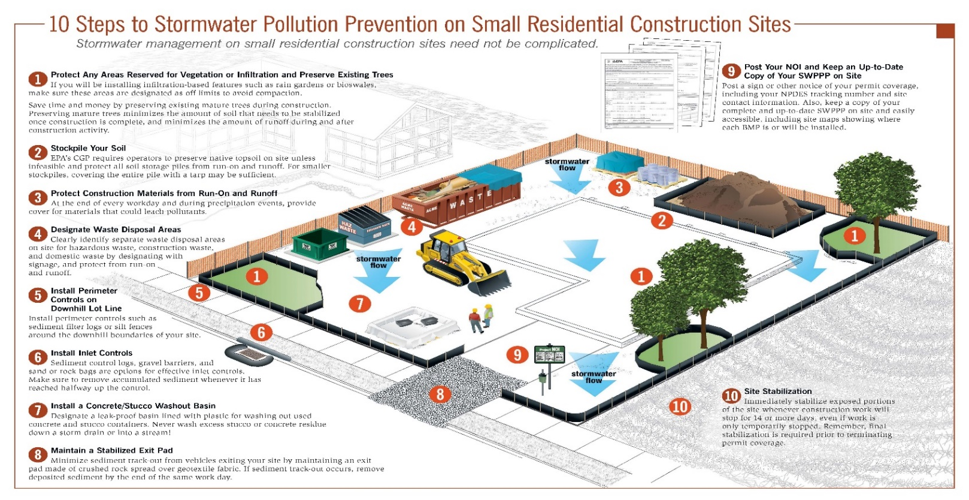
BEST MANAGEMENT PRACTICES (BMP) FOR CONSTRUCTION ACTIVITIES
Residential Projects are required to submit an Erosion Control Plan with Best Management Practices (BMPs) and Good Housekeeping methods. Provide City of Barstow Construction waste Management Plan Application. http://www.barstowca.org/residents/construction-waste-management
The above Best Management Practices are detailed in the California Storm Water Best Management Practices Handbook, January 2003. www.cabmphandbooks.com
https://www.epa.gov/sites/production/files/2015-12/documents/cgp_small_lot_swppp_brochure-508_0.pdf

END OF SFR WQMP TEMPLATE

Phase II Small MS4 General Permit 2013-0001-DWQ, Section E.12.b: all projects that create and/or replace (including projects with no net increase in impervious footprint) between 2,500 square feet and 5,000 square feet of impervious surface, including detached single-family homes that create and/or replace 2,500 square feet or more of impervious surface and are not part of a larger plan of development.
Impervious surface means: NOT ALLOWING FLUID TO PASS THROUGH. In the permit: "A surface covering or pavement of a developed parcel of land that prevents the land's natural ability to absorb and infiltrate rainfall/storm water. Impervious surfaces include, but are not limited to; roof tops, walkways, patios, driveways, parking lots, storage areas, impervious concrete and asphalt, and any other continuous watertight pavement or covering. Landscaped soil and pervious pavement, including pavers with pervious openings and seams, underlain with pervious soil or pervious storage material, such as a gravel layer sufficient to hold the specified volume of rainfall runoff are not impervious surfaces".
§19.08.050(b) (11)
Roof areas larger than 600 square feet will require dissipation method (such as downspout splash guard, river-rock lined swale, etc.) at the impact that will handle the storm flows and not create erosive conditions.
Receiving areas (Hydrozone) are landscaped areas having plants similar water needs clustered together, sometimes referred to as Rain Gardens, River-rock swales, etc. These areas are not plastic lined and are intended for infiltration.
Surface types included but not limited to: Rain Garden, River-Rock lined swale, Tree-well, grass, etc.
Guide to High Desert Landscaping, pg.6
§19.06.080(h)(1)a.1.
PHOTO: https://www.colliertownship.net/159/MS4---Stormwater-Education-Program Additional information: https://nepis.epa.gov/Exe/ZyPDF.cgi/20004PP1.PDF?Dockey=20004PP1.PDF, https://www.epa.gov/nutrientpollution/what-you-can-do-your-yard
Photo: https://www.epa.gov/sites/production/files/2015-12/documents/cgp_small_lot_swppp_brochure-508_0.pdf

